**Lebanese American University**



***COE322 – Logic Design Lab  
Final Project***

***Spring 2025***

Dia Khalil 202301675  
Karim Nehme 202308255  
Michelle Baalbaky 202301560  
Farah Mikhael 202303359

Table of Contents

Table of Figures 4

Table of Tables 5

Abstract 6

Introduction 7

Components and Equipment used 8

Project Analysis 9

Clock design 21

Full Circuit Implementation 23

Financial Study 30

Power consumption 32

Delays 34

Problems Faced 35

# Table of Figures

Figure 1 State Diagram 10

Figure 2:8-to-1 Mux Implementation 22

Figure 3: Quartus Circuit for N1 24

Figure 4 Simulation N1 in BOOT 25

Figure 5 Simulation N1 in SEQ1 25

Figure 6 Simulation N1 in SEQ2 25

Figure 7 Simulation N1 in SEQ3 26

Figure 8 Simulation N1 in SEQ4 26

Figure 9 Simulation N1 in SEQ5 26

Figure 10 Simulation N1 in SEQ6 27

Figure 11 Simulation N1 in SEQ7 27

Figure 12 N1 on Virtual Breadboard 27

Figure 13: Quartus Circuit for N2 28

Figure 14 Simulation N2 in BOOT 28

Figure 15 Simulation N2 in SEQ1 29

Figure 16 Simulation N2 in SEQ2 29

Figure 17 Simulation N2 in SEQ3 29

Figure 18 Simulation N2 in SEQ4 30

Figure 19 Simulation N2 in SEQ5 30

Figure 20 Simulation N2 in SEQ6 30

Figure 21 Simulation N2 in SEQ7 30

Figure 22 Virtual Breadboard for N2 31

Figure 23: Quartus Circuit for N3 31

Figure 24 Simulation N3 Simulation in BOOT 32

Figure 25 Simulation N3 Simulation in SEQ1 32

Figure 26 Simulation N3 in SEQ2 32

Figure 27 Simulation N3 in SEQ3 33

Figure 28 Simulation N3 in SEQ4 33

Figure 29 Simulation N3 in SEQ5 33

Figure 30 Simulation N3 in SEQ6 34

Figure 31 Simulation N3 in SEQ7 34

Figure 32 N3 on Virtual Breadboard 34

Figure 33 Full circuit Showing N1,N2,N3 blocks and D-flip flops 35

Figure 34 Full Circuit Showing L1,L2,L3 and L4 as output of MUX 36

Figure 35 Entire Circuit 37

Figure 36 Simulation of Full Circuit 37

Figure 37: Common cathode breadboard implementation 43

Figure 38:7 segment Boot 44

Figure 39: 7 segment Seq 1 44

Figure 40:7 segment Seq2 45

Figure 41:7 segment Seq3 46

Figure 42:7 segment Seq4 46

Figure 44:7 segment Special Trick 47

Figure 43:7 segment unused state 47

Figure 45:7 segment Locked 48

Figure 46:NE555 Timer Circuit 49

Figure 47: Clock signal output 50

Figure 48:555 pins 51

Figure 49:Resistors and Capacitors used for the clock implementation 52

Figure 50:Monostable timer of 4 s 54

# Table of Tables

Table 1: Truth Table for Boot 11

Table 2: Truth Table for SEQ1 12

Table 3:: Truth Table for SEQ2 12

Table 4: Truth Table for SEQ3 13

Table 5:: Truth Table for SEQ4 13

Table 6: Truth Table for SPECIAL TRICK 14

Table 7: Truth Table for LOCKED 15

Table 8: Truth Table for COUNTER 16

Table 9: Outputs in BOOT State 17

Table 10: Outputs in SEQ1 State 17

Table 11: Outputs in SEQ2 State 18

Table 12: Outputs in SEQ2 State 18

Table 13: Outputs in SEQ4 State 19

Table 14: Outputs in SPECIAL TRICK State 19

Table 15: Outputs in LOCKED State 20

Table 16: Truth table for the 7 segment 39

Table 17:K-map of a 39

Table 18: K-map of b 40

Table 19:K-map of c 40

Table 20:K-map of d 40

Table 21:K-map of e 41

Table 22:K-map of f 41

Table 23:K-map of g 42

Table : Price List 56

Table : Delay Table 59

# Abstract

This report presents the design and implementation of a Logic-Controlled Board, a dynamic switching system where switches are used to activate LEDs of colors red, green, blue, and yellow. Initially, each switch is mapped to a lamp of the same color, but the system reconfigures the LEDs' activation based on the last switch turned off, creating an illusion of a magic switch box. Users can rearrange switch caps and lamp positions while maintaining correct color-to-switch mapping. The user might not understand the logic behind the circuit as it would appear as controlled by the magician. In fact, the choice of behavior is limited and made depending on the states following a certain logic.

The system employs digital logic circuits, memory elements, and finite state machines (FSMs) to track switch states and adjust lamp behavior in real time. This project demonstrates the application of sequential logic design in creating adaptable and interactive systems. The principles explored can be extended to real-world applications such as elevator controls, vending machines, traffic light systems, and interactive digital games, bringing together theoretical concepts and integrating them with practical solutions. Through this implementation, the report highlights the versatility of logic design in mimicking and enhancing everyday digital systems.

# Introduction

The Logic-Controlled Board is a dynamic switching system designed to create an engaging illusion where lamps respond intelligently based on the last switch turned off. To get to a fully functional implementation of the Logic Controlled Board, extended research was conducted to understand the behavior of the system. To be able to translate our logic into a physical prototype, we started by designing a state machine responsible of dividing logical operations corresponding to the required operation. The states depend on the conditions of each expected outcome.

We then proceeded by getting the equations for each of our chosen outputs based on the corresponding inputs. This was done using Karnaugh Map software. We then simplified the corresponding equations in a way that allowed us to reuse combinations and avoid the excessive use of logical gates.

To be able to make sure of our design, we implemented the derived equations on Altera Quartus II software and obtained successful results. The next step was testing our implementation on Virtual Breadboard to set up a plan that allowed us to avoid having a messy physical implementation.

After the physical implementation on breadboard and separate testing of our circuits, we joint the entire system and made sure again of the results obtained.

# Components and Equipment used

**Boards**

**ICs and chips:**

74LS08

74LS32

74LS04

74LS74

74LS47

74LS86

74LS151

7 Segment Common Cathode

**Resistors:**

220 $Ω$ Resistors

100 $kΩ$ Resistor

10 $kΩ$ Resistor

2.2 $kΩ$ Resistor

**LEDs:**

Green LED

Yellow LED

Red LED

Orange LED

White LED

Switches

9V Power Supply

Jumping Wires

# Project Analysis

**K-Maps for Outputs:**

**The input variables present in our State Table are:**

S1 S2 S3 S4

**The current States are represented by:**

C3 C2 C1

**The outputs correspond to:**

L1 L2 L3 L4

**The next states are named:**

N1 N2 N3

**The States are the following:**

* BOOT
* LOCKED
* SEQ1
* SEQ2
* SEQ3
* SEQ4
* SPECIAL TRICK

The State Diagram is shown below:

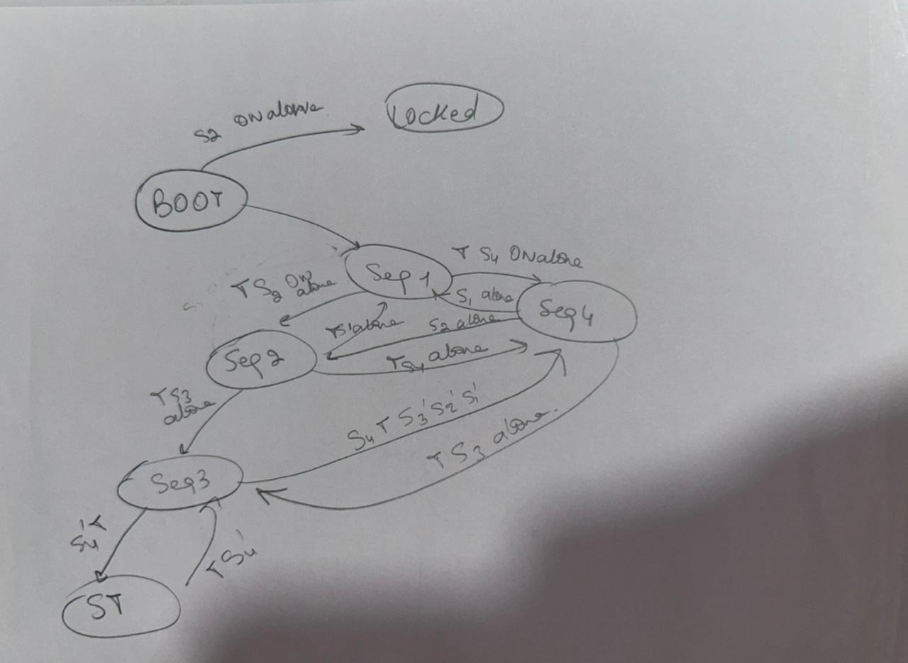

Figure 1 State Diagram

Initially, the system will be in the BOOT state then, based on S2 it will either go to the LOCKED state if S2 is high alone or go to sequence 1 otherwise. In sequence 1, if after 4 seconds (T=1), S2 or S3 or S4 is high alone, the design will go to sequence 2 or 3 or 4 respectively. Similarly, in seq2 and 4, based on the last switch turned off, the system will go to the corresponding sequence. In sequence 3, the system can only go to sequence 4 if S4 is found ON alone after 4 seconds otherwise it either stays in sequence 3 or goes to the special trick based on switch 4 if it is high or low respectively.

For the State Tables, we used the variables named above and filled their truth tables depending on each state’s behavior:

Table 1: Truth Table for Boot

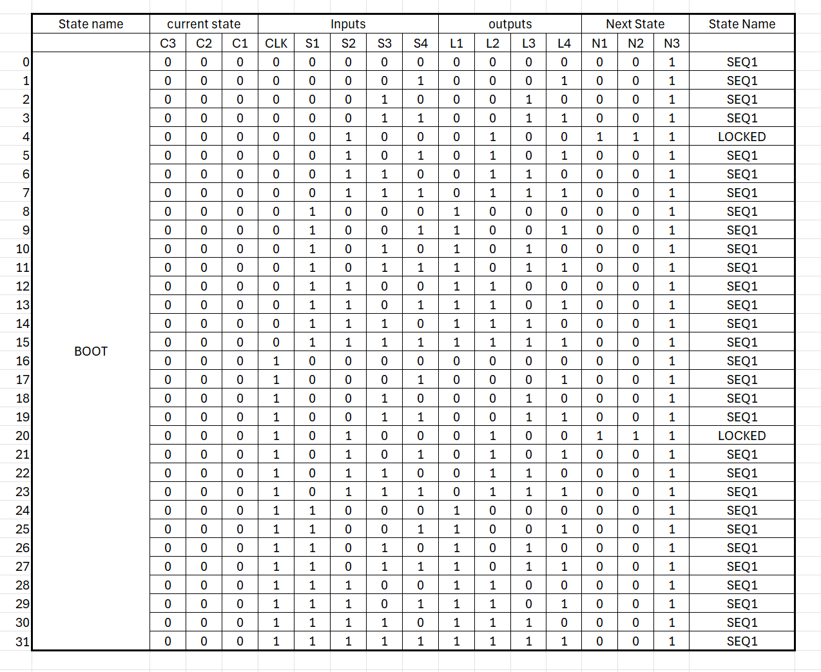

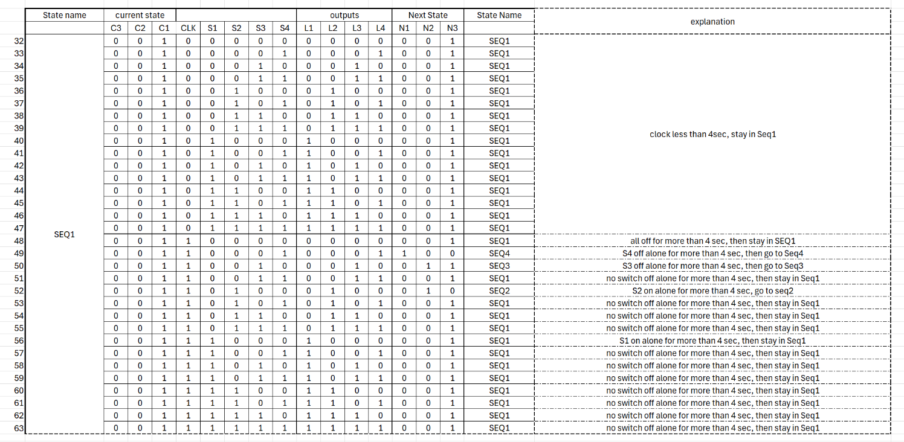

Table 2: Truth Table for SEQ1

Table 3:: Truth Table for SEQ2

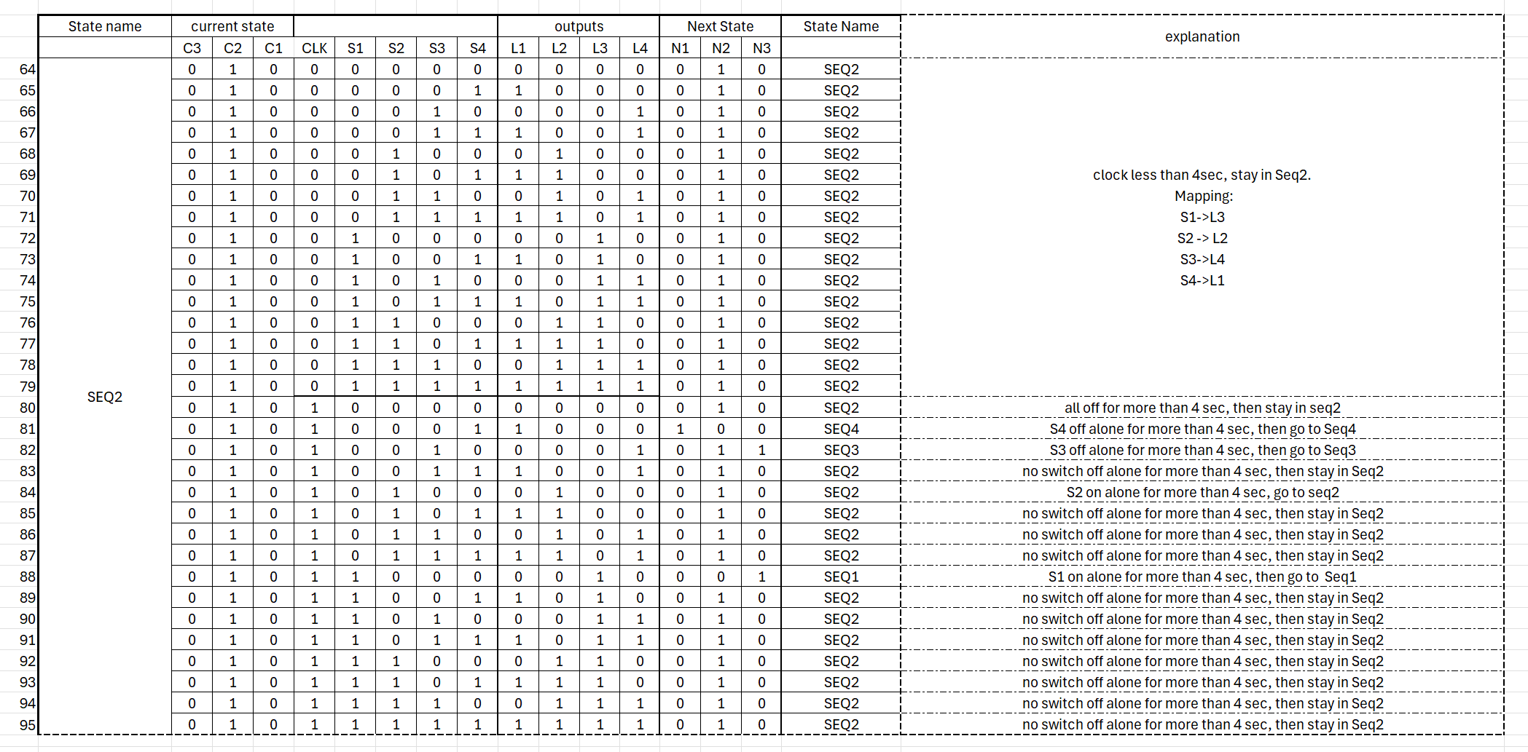

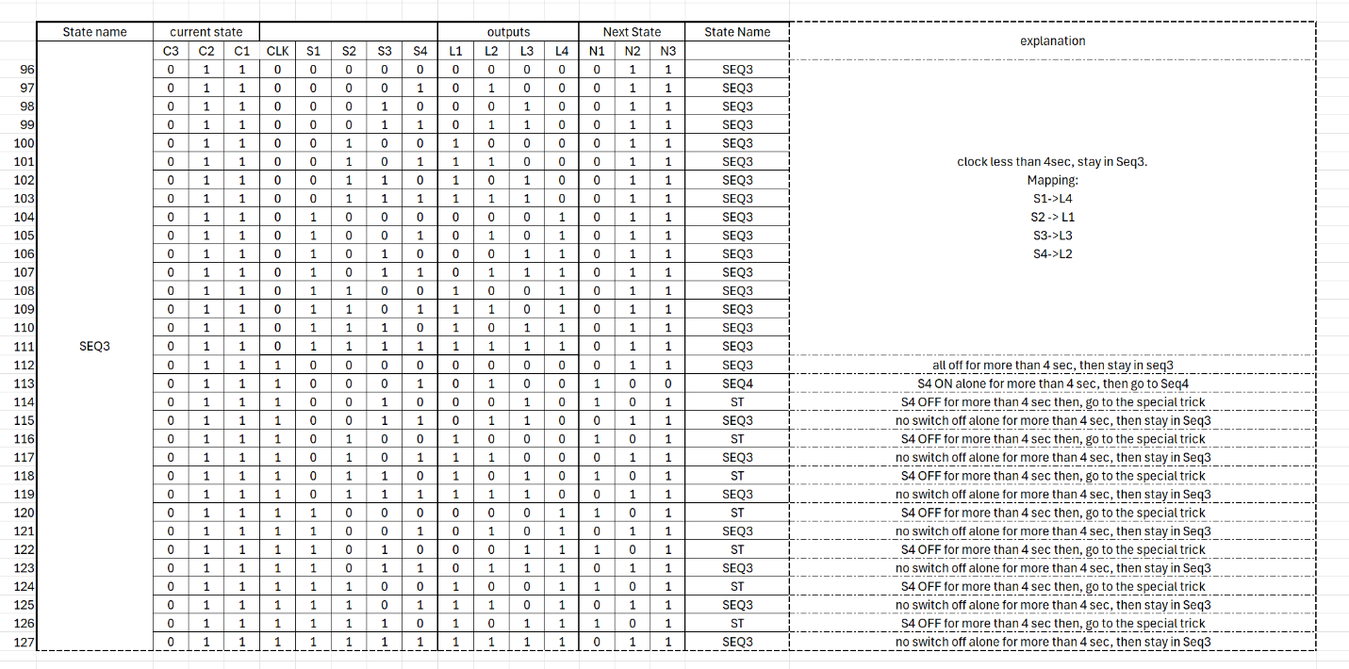

Table 4: Truth Table for SEQ3

Table 5:: Truth Table for SEQ4

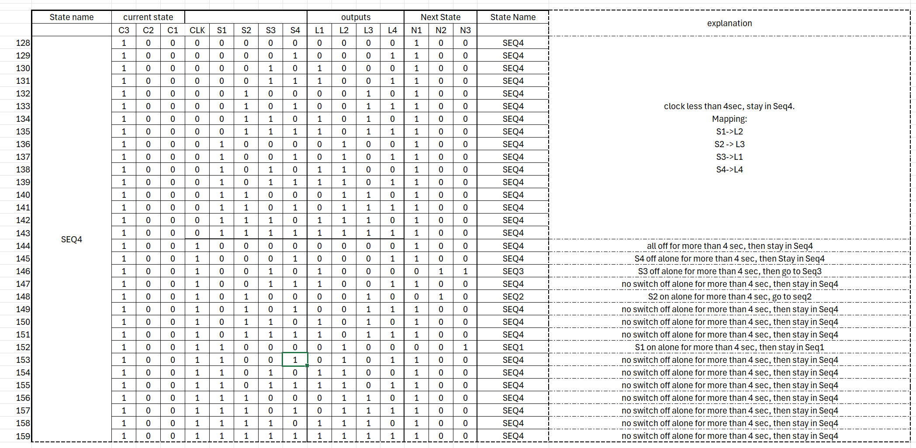

Table 6: Truth Table for SPECIAL TRICK

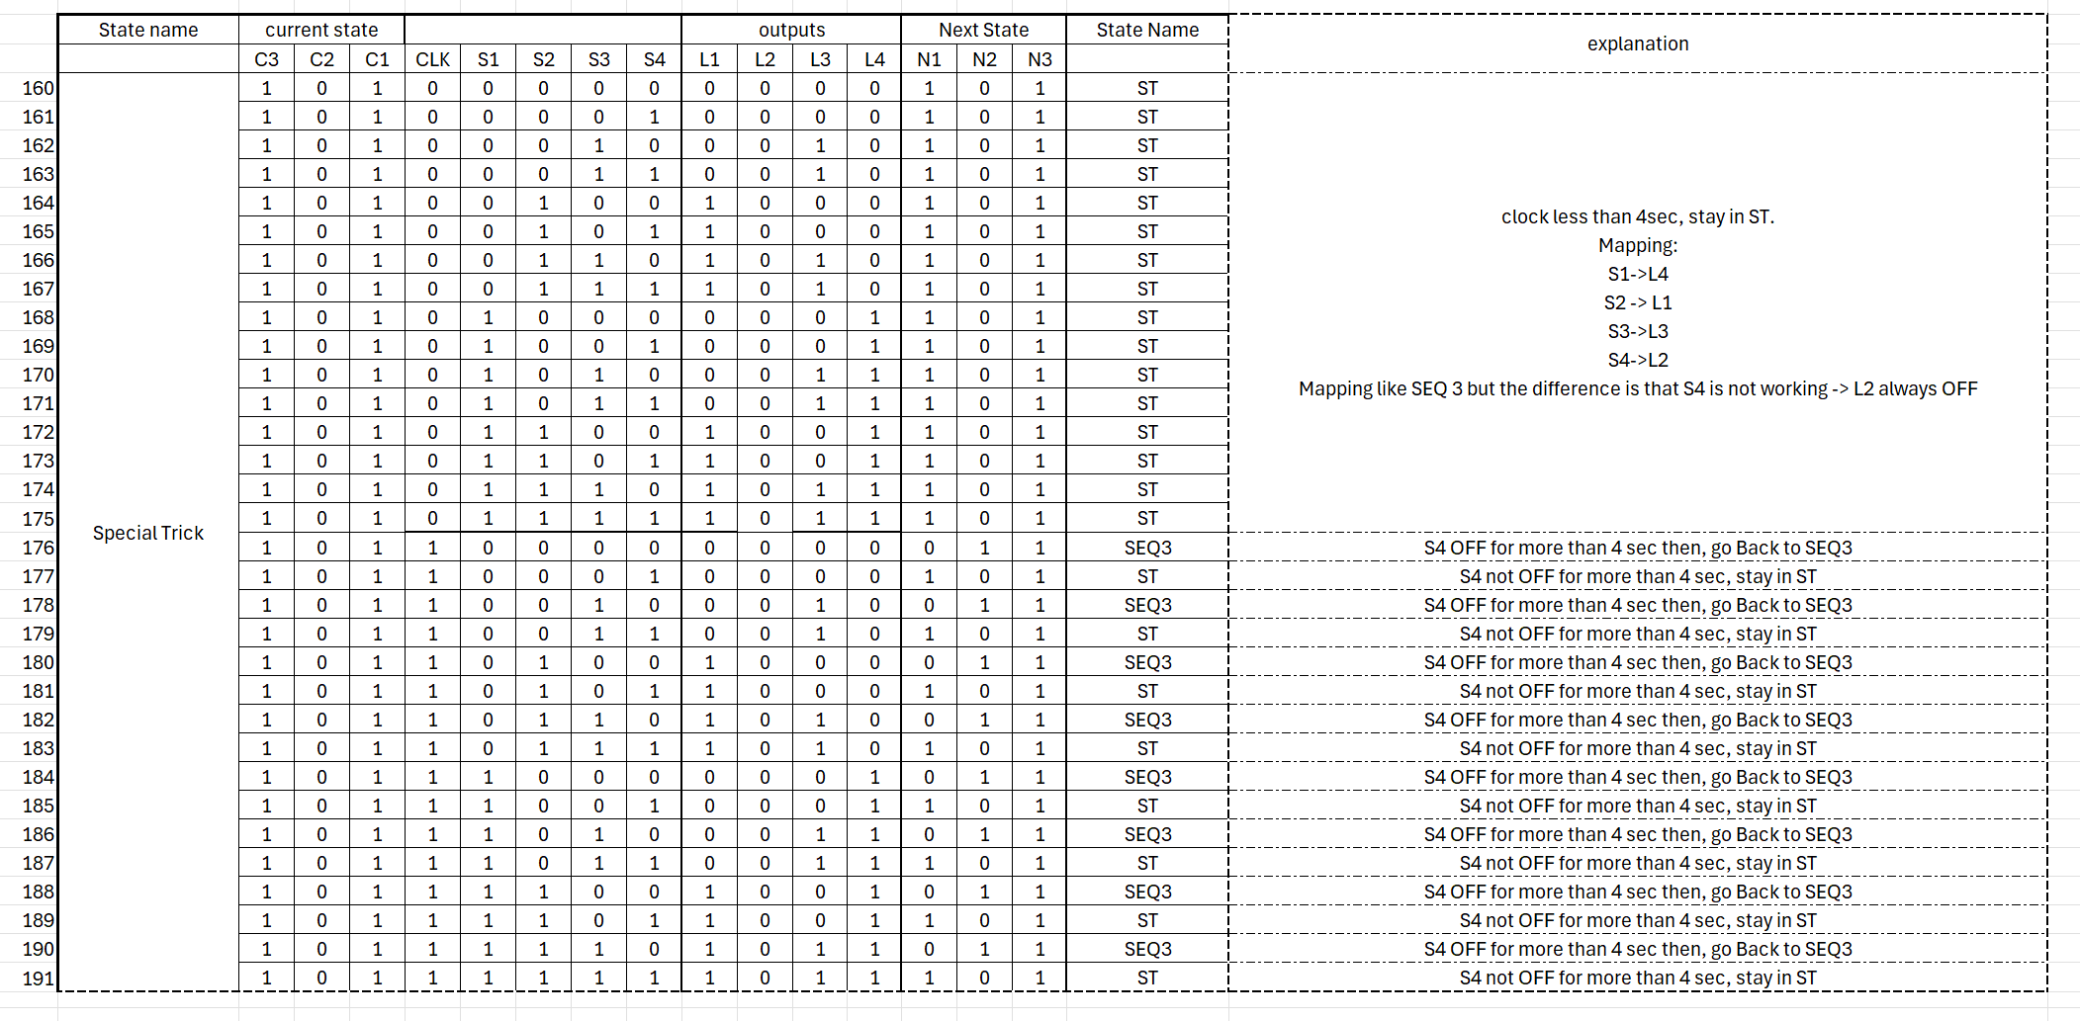

Table 7: Truth Table for LOCKED

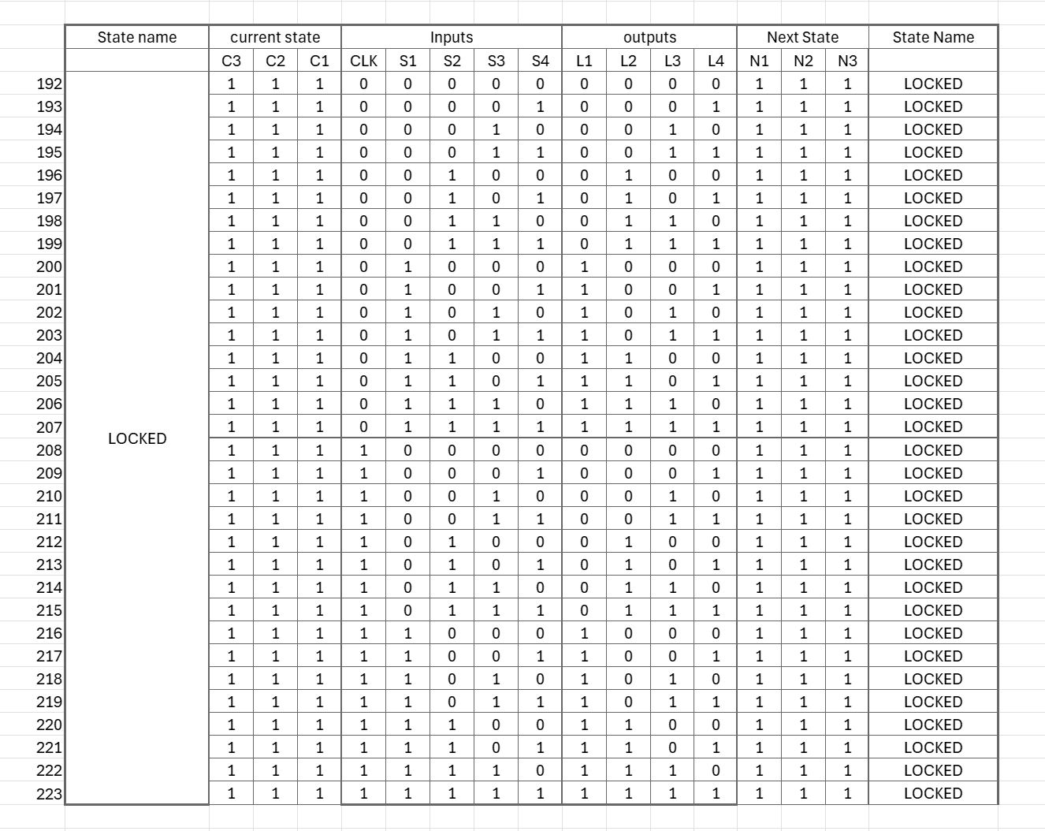

In addition to the obtained states, we derived the truth table corresponding to the desired wait time of 4 seconds using a counter’s format:

Table 8: Truth Table for COUNTER

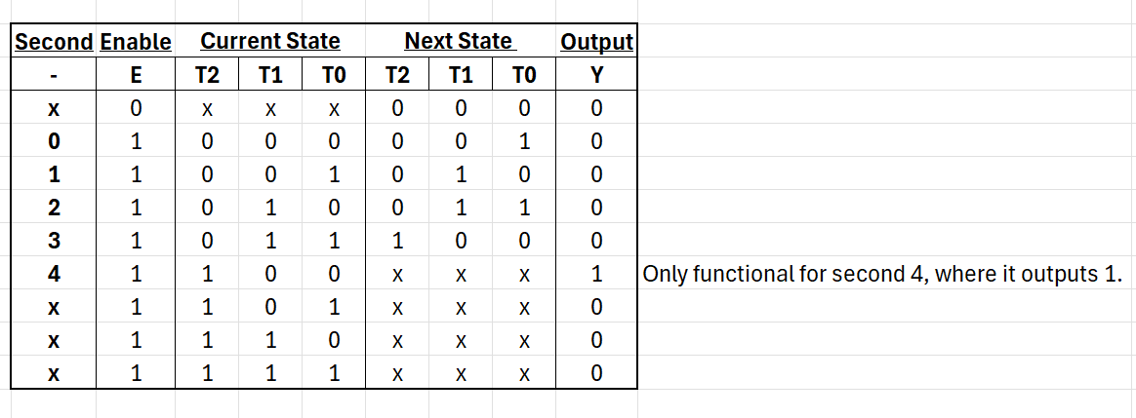

After filling in the truth tables, we derived the expressions respective to each output and state. This was done with the help of Karnaugh Maps.

The derived expressions were assembled together to simulate states using an 8:1 Multiplexer design.

Table 9: Outputs in BOOT State

|  |  |  |
| --- | --- | --- |
| State | Output | Expression |
| BOOT | L1 | S1 |
| L2 | S2 |
| L3 | S3 |
| L4 | S4 |
| N1 | S1'S2S3'S4' |
| N2 | S1'S2S3'S4' |
| N3 | 1 |

Table 10: Outputs in SEQ1 State

|  |  |  |
| --- | --- | --- |
| State | Output | Expression |
| SEQ1 | L1 | S1 |
| L2 | S2 |
| L3 | S3 |
| L4 | S4 |
| N1 | TS1’S2’S3’S4 |
| N2 | TS1'S4'(S2 XOR S3) |
| N3 | T’ + S1+S3 + (S2 XOR S4)’ |

Table 11: Outputs in SEQ2 State

|  |  |  |
| --- | --- | --- |
| State | Output | Expression |
| SEQ2 | L1 | S4 |
| L2 | S2 |
| L3 | S1 |
| L4 | S3 |
| N1 | TS1’S2’S3’S4 |
| N2 | T' + S2 + S3 + (S1 XNOR S4) |
| N3 | TS1'S2'S3 S4'+TS1S2'S3'S4' |

Table 12: Outputs in SEQ2 State

|  |  |  |
| --- | --- | --- |
| State | Output | Expression |
| SEQ3 | L1 | S2 |
| L2 | S4 |
| L3 | S3 |
| L4 | S1 |
| N1 | TS1'S2'S3'S4+TS1S4'+TS2S4'+TS3S4' |
| N2 | T' + S1'S2'S3'S4' + S4(S1 + S2 + S3) |
| N3 | T'+S1+S2+S3+S4' |

Table 13: Outputs in SEQ4 State

|  |  |  |
| --- | --- | --- |
| State | Output | Expression |
| SEQ4 | L1 | S3 |
| L2 | S1 |
| L3 | S2 |
| L4 | S4 |
| N1 | T'+S1'S2'S3'+S1(S2+S3)+S2S3+S4 |
| N2 | = TS1'S4'(S2 XOR S3) |
| N3 | T S2' S4'(S1 XOR S3) |

Table 14: Outputs in SPECIAL TRICK State

|  |  |  |
| --- | --- | --- |
| State | Output | Expression |
| SPECIAL TRICK | L1 | S2 |
| L2 | 0 |
| L3 | S3 |
| L4 | S1 |
| N1 | T'+S4 |
| N2 | TS4' |
| N3 | 1 |

Table 15: Outputs in LOCKED State

|  |  |  |
| --- | --- | --- |
| State | Output | Expression |
| LOCKED | L1 | S1 |
| L2 | S2 |
| L3 | S3 |
| L4 | S4 |
| N1 | 1 |
| N2 | 1 |
| N3 | 1 |

For the above tables, We need 4 separate 8-to-1 multiplexers, one for each output (L1, L2, L3, L4).

1. **State Encoding**:
   * BOOT: 000
   * SEQ1: 001
   * SEQ2: 010
   * SEQ3: 011
   * SEQ4: 100
   * ST: 101
   * State 110: GROUNDED
   * LOCKED: 111
2. **Control Signals**: The selection lines for each MUX are the state bits (C3,C2,C1).

**How MUX Works**

Each 8-to-1 multiplexer has:

* 8 data inputs (I₀ through I₇)
* 3 select lines (C3,C2,C1) that determine which input is connected to the output
* 1 output (L1, L2, L3, or L4)

The select lines correspond to the state encoding bits. For example, when the state is BOOT (000), input I0 of each MUX is selected. When the state is SEQ1 (001), input I1 is selected, and so on.

**Each MUX Is Summarized as Follows:**

**L1 MUX (Blue):**

* BOOT (000): Outputs S₁
* SEQ1 (001): Outputs S₁
* SEQ2 (010): Outputs S₄
* SEQ3 (011): Outputs S₂
* SEQ4 (100): Outputs S₃
* ST (101): Outputs S₂
* 110: Grounded (0)
* LOCKED (111): Outputs S₁

**L2 MUX (Red):**

* BOOT (000): Outputs S₂
* SEQ1 (001): Outputs S₂
* SEQ2 (010): Outputs S₂
* SEQ3 (011): Outputs S₄
* SEQ4 (100): Outputs S₁
* ST (101): Outputs 0
* 110: Grounded (0)
* LOCKED (111): Outputs S₂

**L3 MUX (Green):**

* BOOT (000): Outputs S₃
* SEQ1 (001): Outputs S₃
* SEQ2 (010): Outputs S₁
* SEQ3 (011): Outputs S₃
* SEQ4 (100): Outputs S₂
* ST (101): Outputs S₃
* 110: Grounded (0)
* LOCKED (111): Outputs S₃

**L4 MUX (Orange):**

* BOOT (000): Outputs S₄
* SEQ1 (001): Outputs S₄
* SEQ2 (010): Outputs S₃
* SEQ3 (011): Outputs S₁
* SEQ4 (100): Outputs S₄
* ST (101): Outputs S₁
* 110: Grounded (0)
* LOCKED (111): Outputs S₄

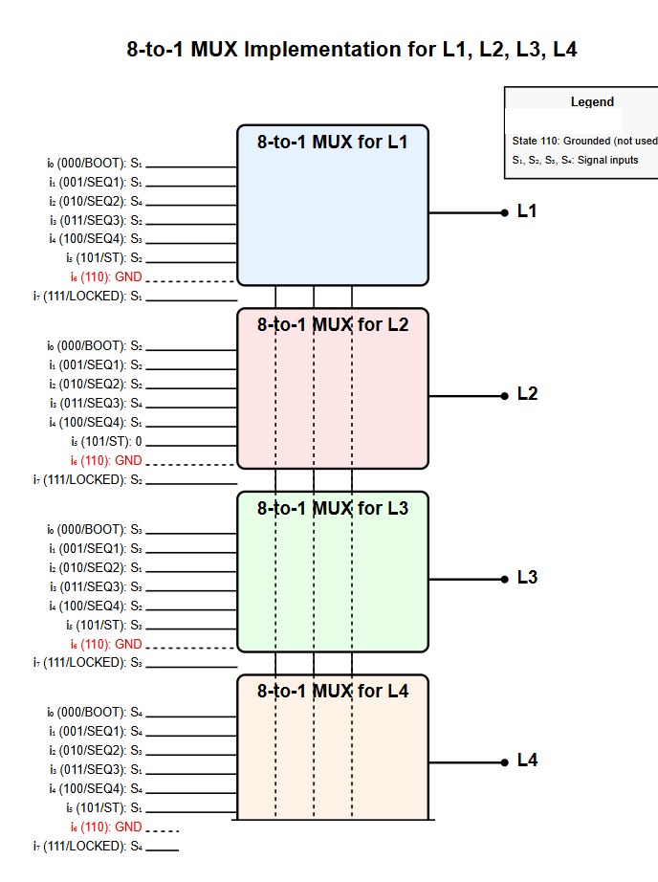

Figure 2:8-to-1 Mux Implementation

We implemented the following crcuit on breadboard and ensure all Vcc are connedted to the power supply for the muxes and similarly for the ground.We also connect the enable pin to the ground.

S1: white (7-1)

S2: red (2)

S3: green (3)

* S4: purple (5-4)
* I6: PIN 13 GROUND
* VCC: YELLOW
* Ground: Black
* PIN 5: L1 OUTPUT BLUE nb on breadboard 8
* S2🡪C3 PIN 9 brown
* S1🡪C2 PIN 10 orange
* S0🡪C1 PIN 11 yellow

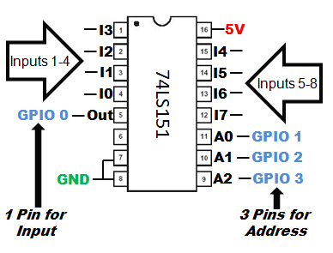

Figure 3:8-1 mux pins

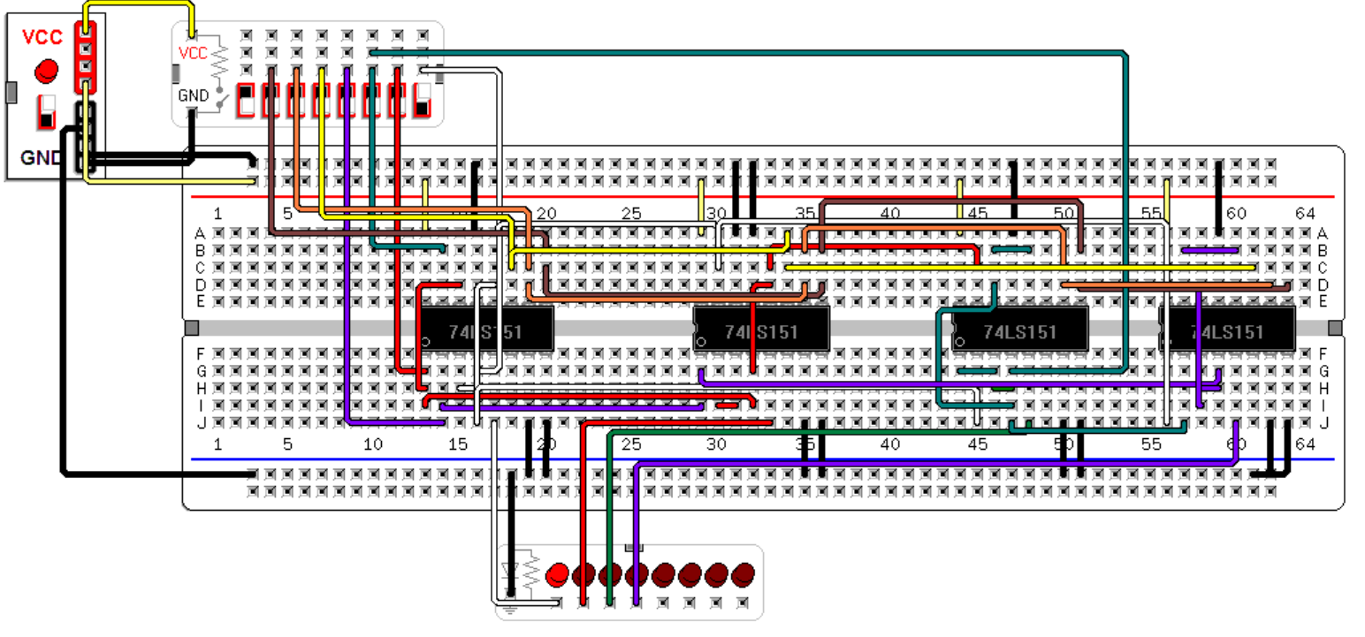

Figure 4:Boot L1=1

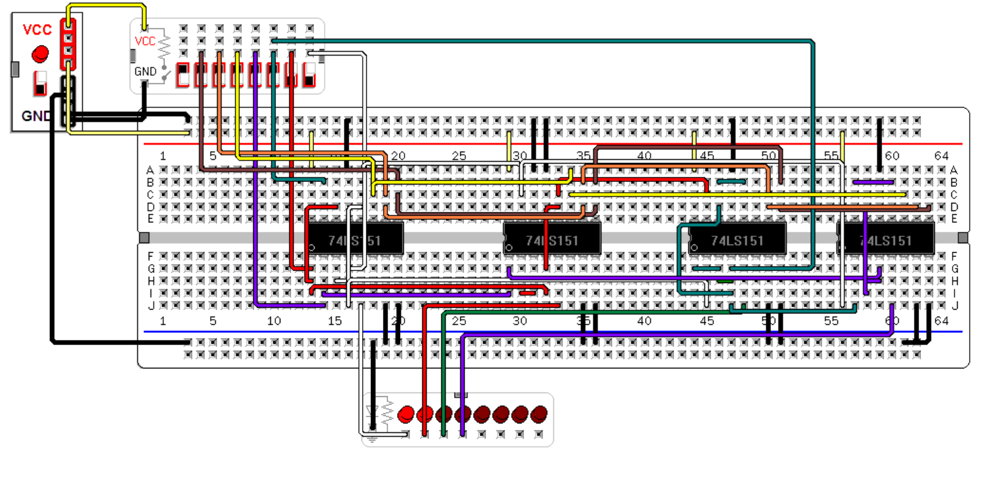

Figure 5:Boot L2=1

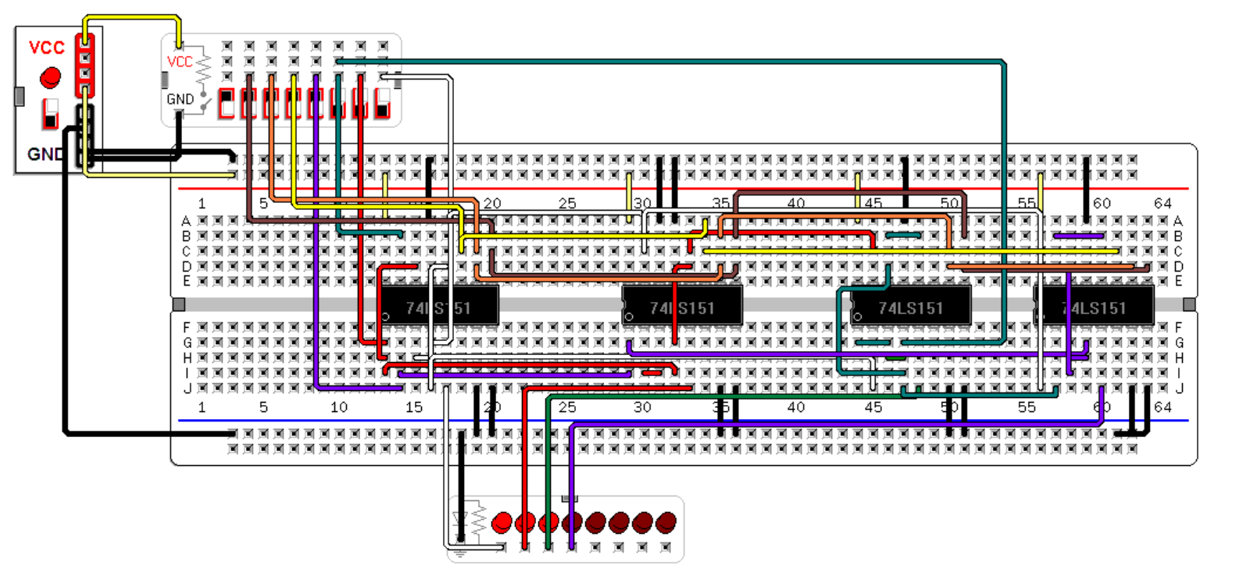

Figure 6:Boot L3=1

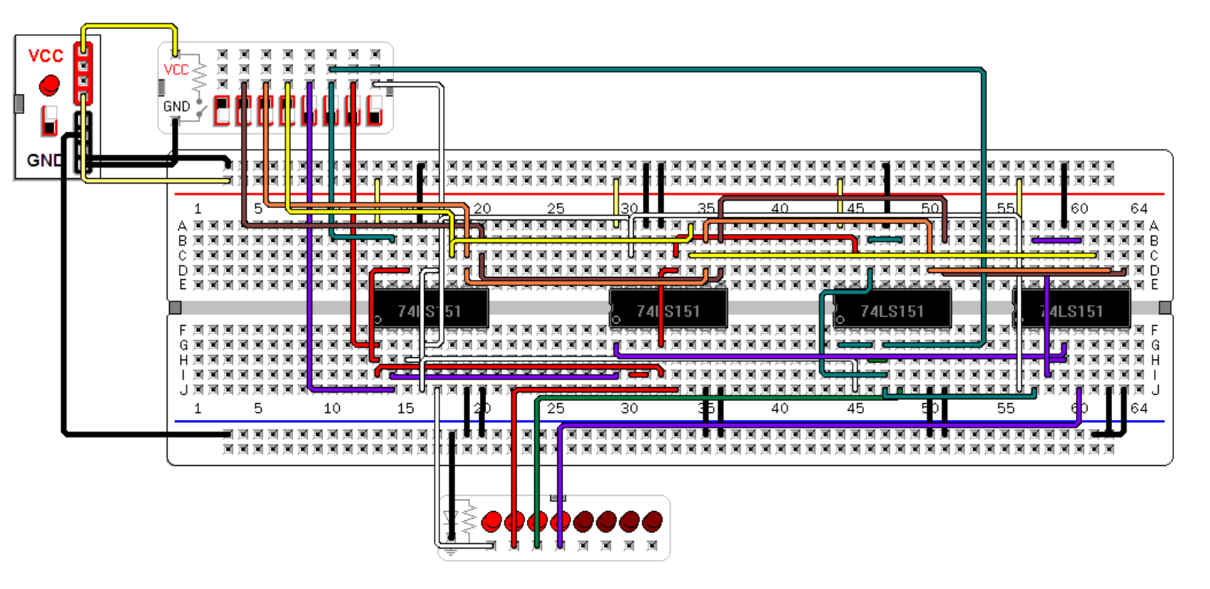

Figure 7:Boot L4=1

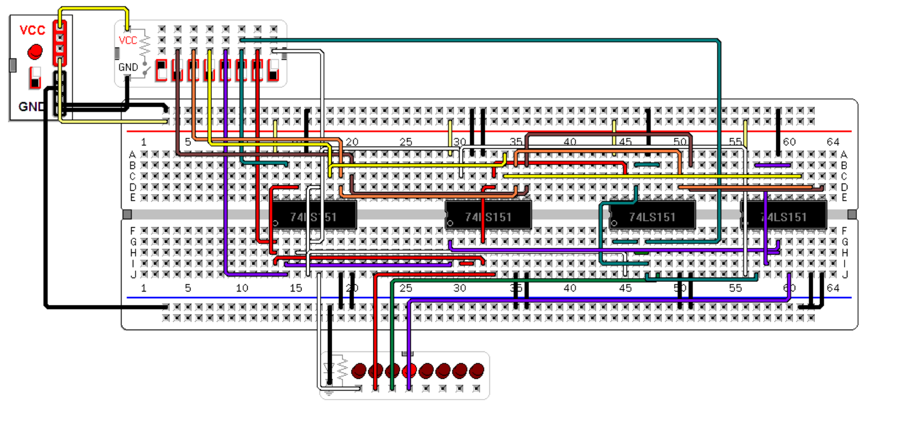

Figure 8:Special trick S1 light L4

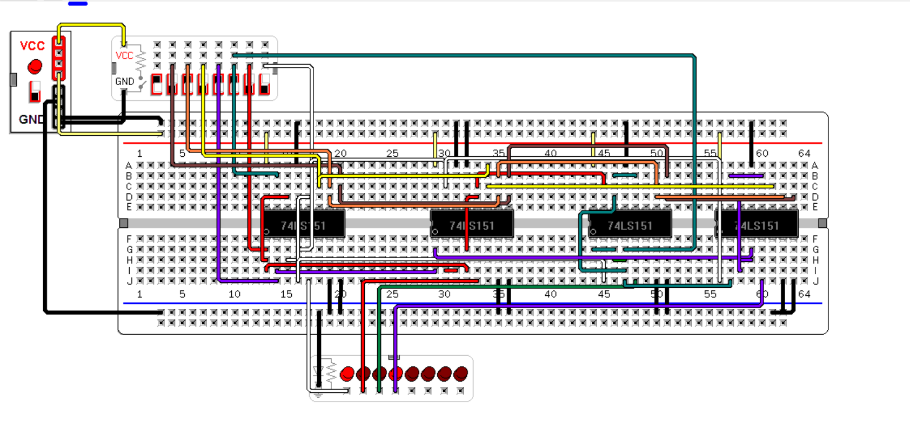

Figure 9:Special trick S2 light L1

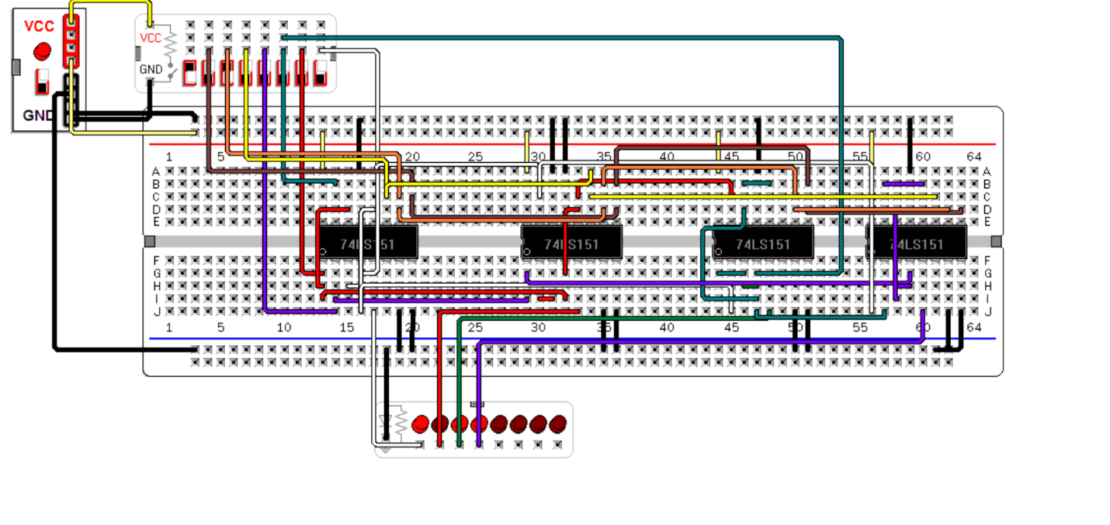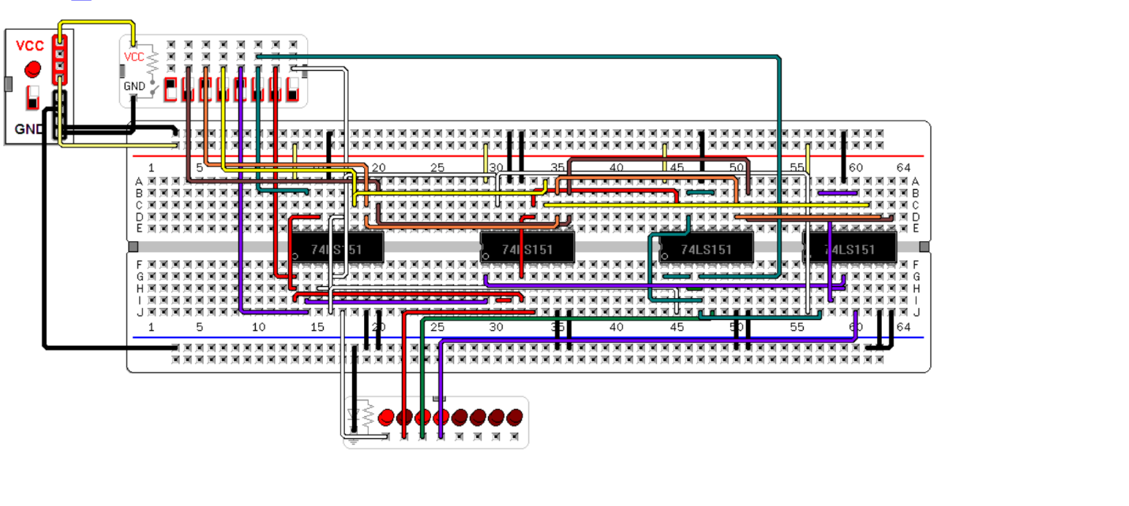

Figure 10:Special trick S3 light L3

Figure 11:Special trick S4 keeps L2 Off

# Full Circuit Implementation

We proceeded by implementing our design on ALTERA QUARTUS II software:

The most significant bit N1 of the current state is implemented using a 1 to 8 MUX where each input from I0 to I7 corresponds to a circuit design based on the simplified equations.

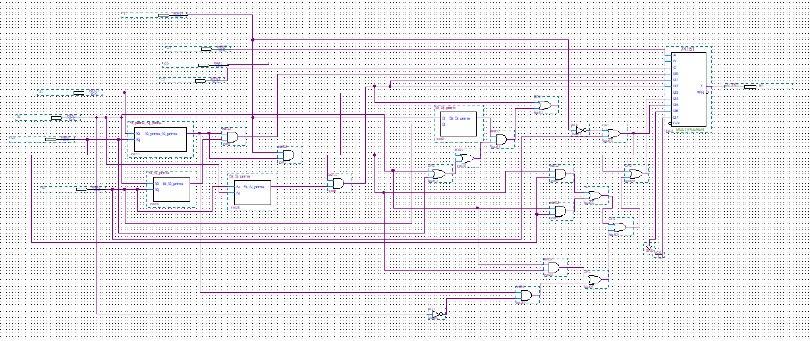

Figure 12: Quartus Circuit for N1

The full simulation for N1 was done using the select lines as inputs: C1, C2 and C3 where C3 is the most significant bit of the next state and C1 is the lest significant.

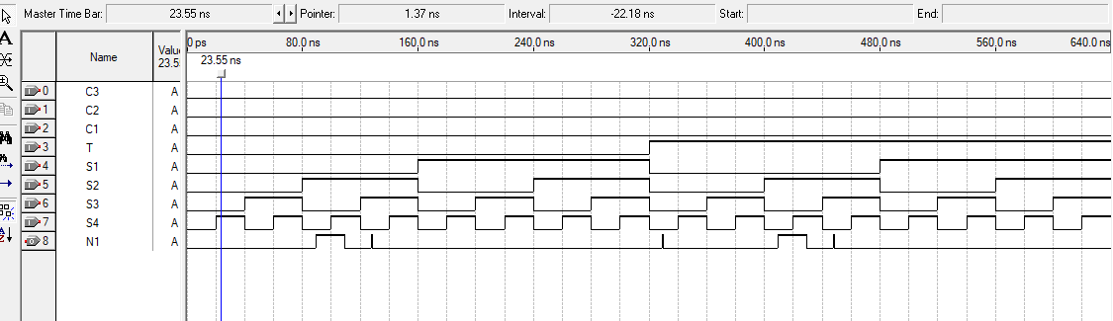

Figure 13 Simulation N1 in BOOT

In the BOOT state, the most significant bit of the state is 0 except when S2 is ON alone because the system goes to the LOCKED state which is 111.

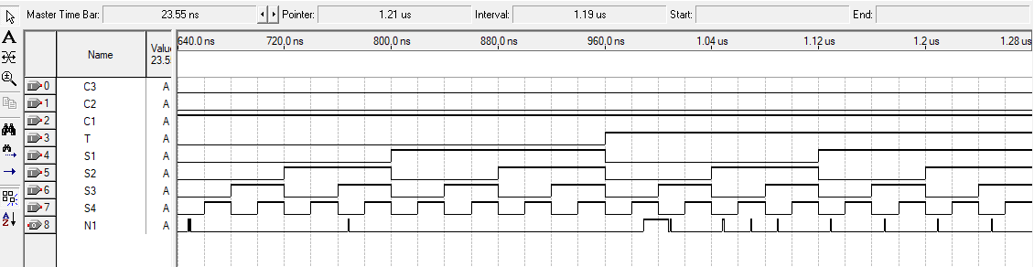

Figure 14 Simulation N1 in SEQ1

In SEQ1, N1 is always 0 except when switch 4 is ON alone since the system goes to sequence 100 in this case.

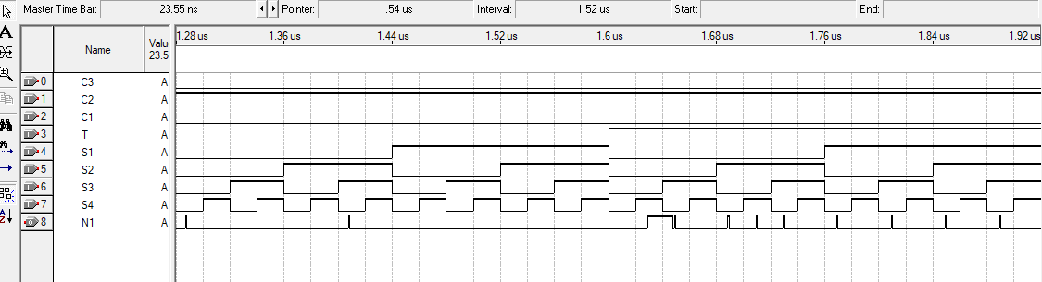

Figure 15 Simulation N1 in SEQ2

N1 is always 0 in this case since it stays in sequence 010 except when S4 is ON alone with T=1 then, the system goes to sequence 100.

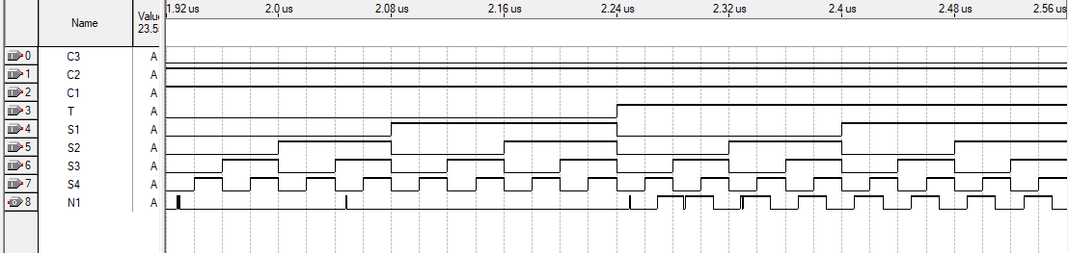

Figure 16 Simulation N1 in SEQ3

In this sequence, N1 is always LOW since the system stays in sequence 011. Then, after 4 seconds, the system goes to sequence 100 if switch 4 in ON alone or to the special trick if switch 4 is OFF with T=1. In these cases, N1 should be high since the system goes to sequences 100 or 101.

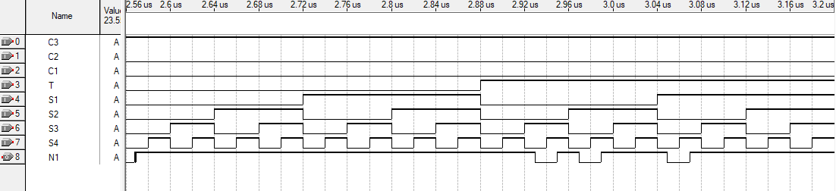

Figure 17 Simulation N1 in SEQ4

In this sequence, N1 is always high since the system stays in sequence 100. However, when T is high and S3 or S1 or S2 is high alone, N1 becomes 0 since the system goes to sequence 011 or 001 or 010 respectively.

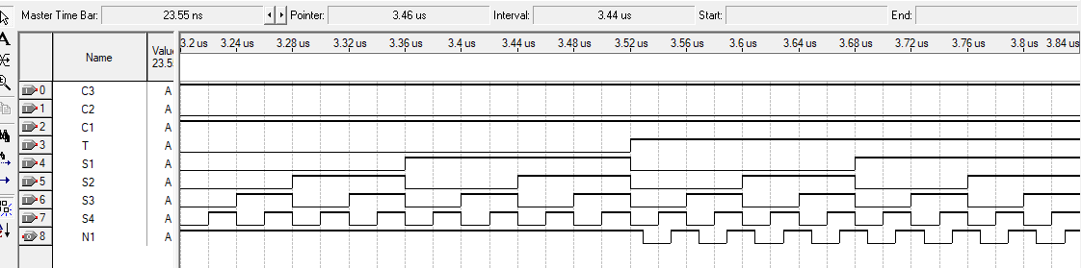

Figure 18 Simulation N1 in SEQ5

In sequence 5, the system always stays in sequence 101 when T is 0 then N1 = 0. Then, when T is high with S4 off, the system goes to sequence 010 then N1 is LOW.

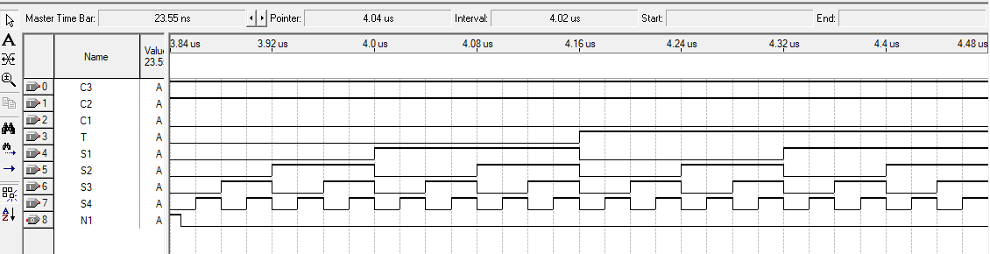

Figure 19 Simulation N1 in SEQ6

Sequence 110 is unused, then N1 is grounded to go to the boot.

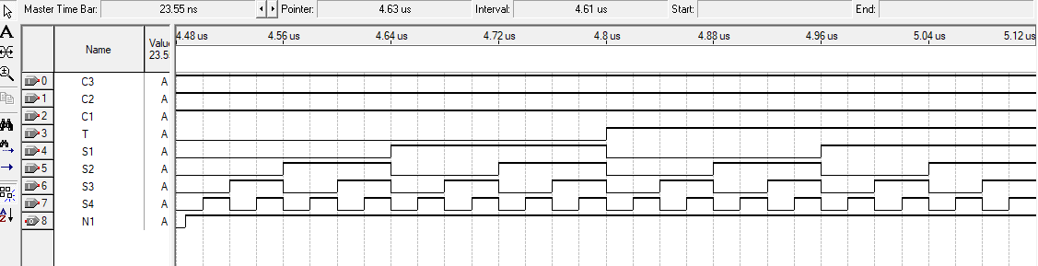

Figure 20 Simulation N1 in SEQ7

Sequence 7 is LOCKED state then N1 is always high.

The implementation of N1 on virtual breadboard is done and shown in the following screenshot:

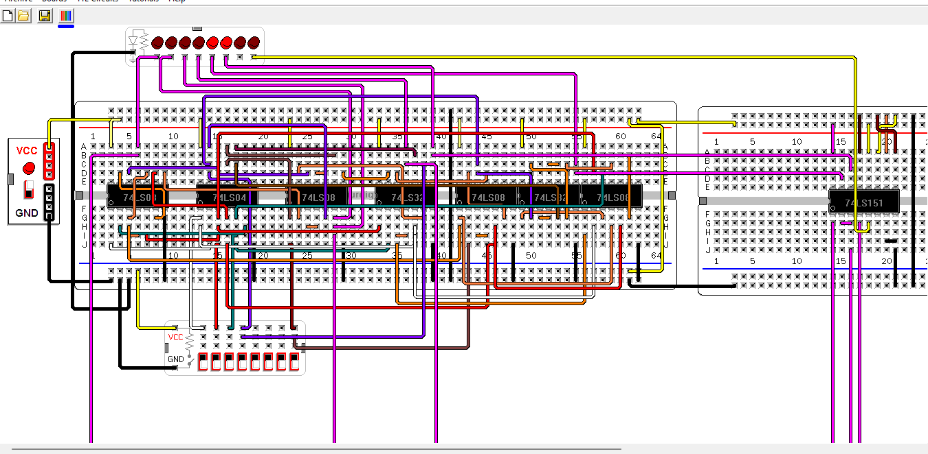

Figure 21 N1 on Virtual Breadboard

In this implementation, all the switches are OFF, the LEDs show the outputs in BOOT, seq1, seq2, seq3, seq4 and seq5 respectively. As expected, the output of N1 is high only in sequences 100 and 101.

Now, similarly to N1, N2 is implemented on Quartus using 8 to 1 MUX as shown in the below circuit:

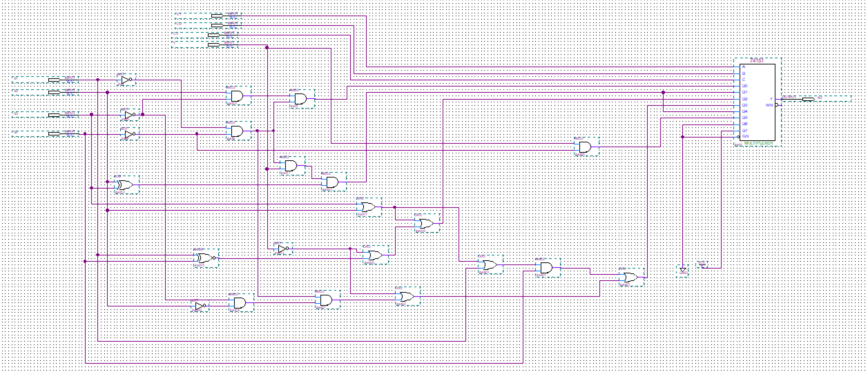

Figure 22: Quartus Circuit for N2

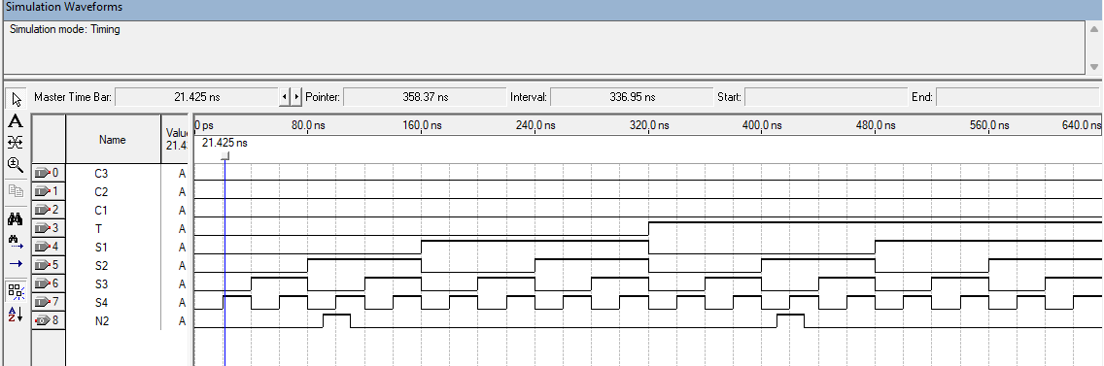

Figure 23 Simulation N2 in BOOT

As expected, N2 is only high when S2 is ON alone since the system goes to 111 in this case.

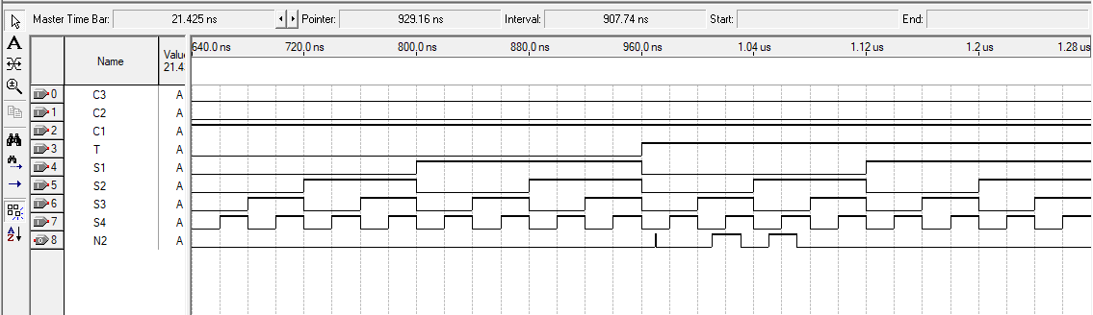

Figure 24 Simulation N2 in SEQ1

In this sequence, the output is always LOW (state 001) except when switch 3 or switch 2 is ON alone since the system goes to sequences 011 or 010 in these cases with T = 1.

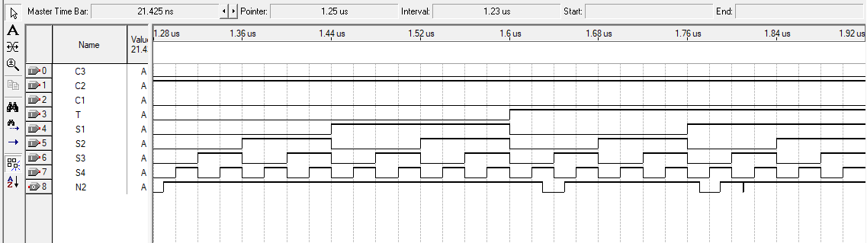

Figure 25 Simulation N2 in SEQ2

As expected, N2 is always high in sequence 010 except when S4 is ON alone or S1 in ON alone to go to sequences 100 or 001 respectively.

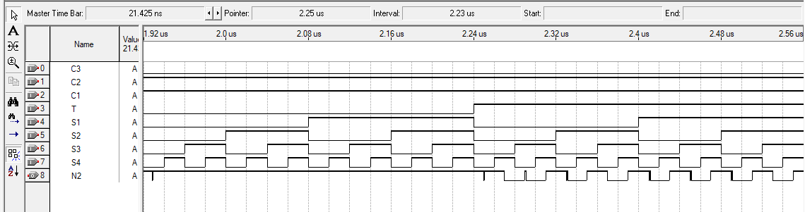

Figure 26 Simulation N2 in SEQ3

N2 is always high in sequence 011 except when T is 1 and S4 is on alone or S4 is off for more than 4 seconds the system goes to state 100 or 101 which means N2 is low.

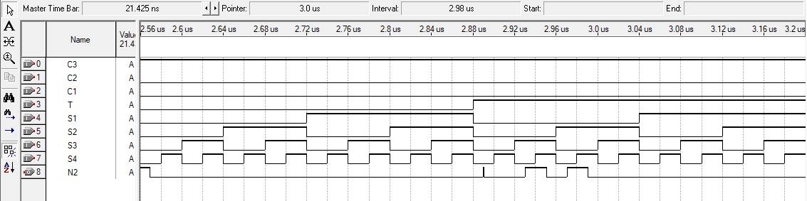

Figure 27 Simulation N2 in SEQ4

In this sequence, S2 is always low except when S3 or S2 is on alone for more than 4 seconds to go to sequences 011 or 010.

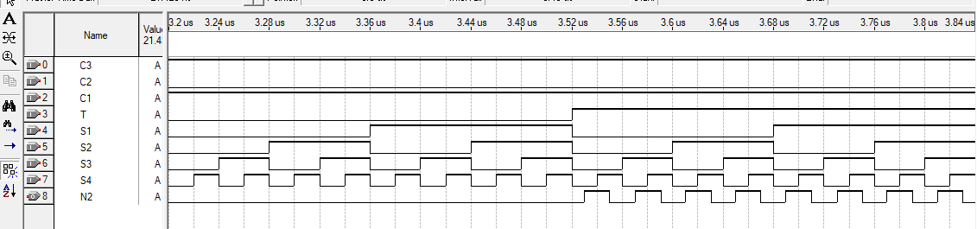

Figure 28 Simulation N2 in SEQ5

In sequence 101, N2 is always low except when T is high with S4 low which means the system goes to sequence 011.

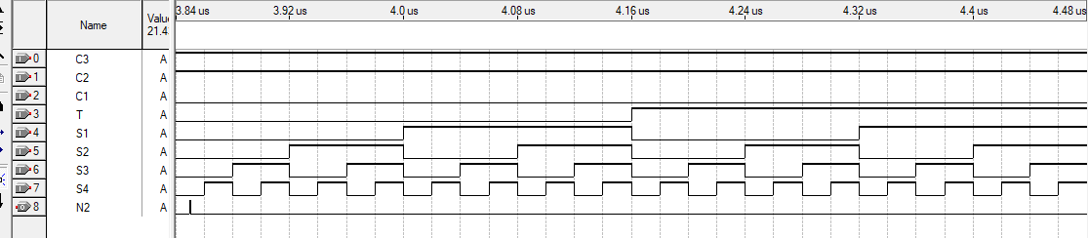

Figure 29 Simulation N2 in SEQ6

Unused state, N2 grounded.

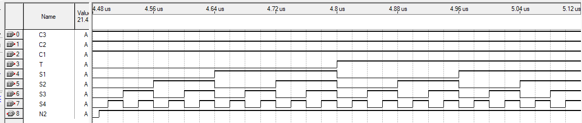

Figure 30 Simulation N2 in SEQ7

Locked state N2 always 1.

A virtual breadboard implementation is done for N2 and shown in the following figure:

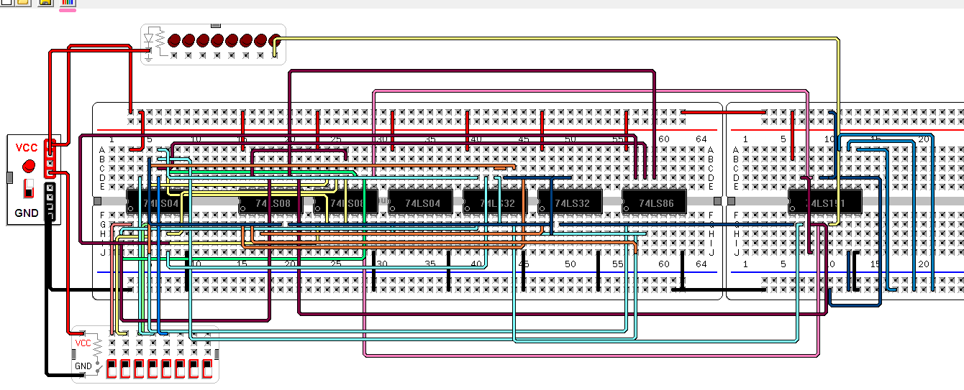

Figure 31 Virtual Breadboard for N2 in BOOT all Switches OFF

As an example, the output of the multiplexer N2 is shown when all select lines are grounded which means the system is in BOOT, it goes to SEQ1 001 then N2 is low as expected. As another example, we test SEQ1 with select lines 001 and all the switches are off, N2 should be OFF.

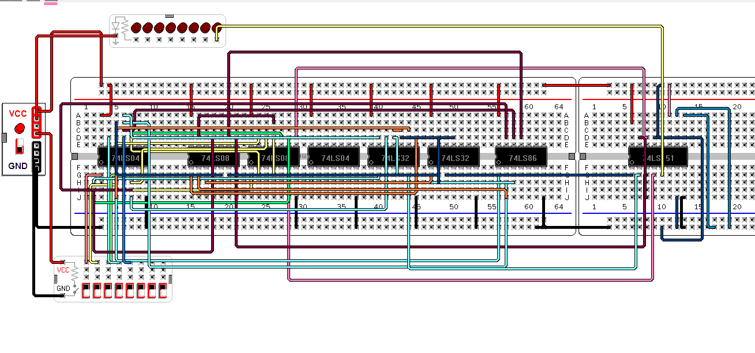

Figure 32 Virtual Breadboard for N2 in SEQ1 with all Switches OFF

All the other combinations were tested and gave the expected output.

Similarly, N3 is implemented on Quartus as follows:

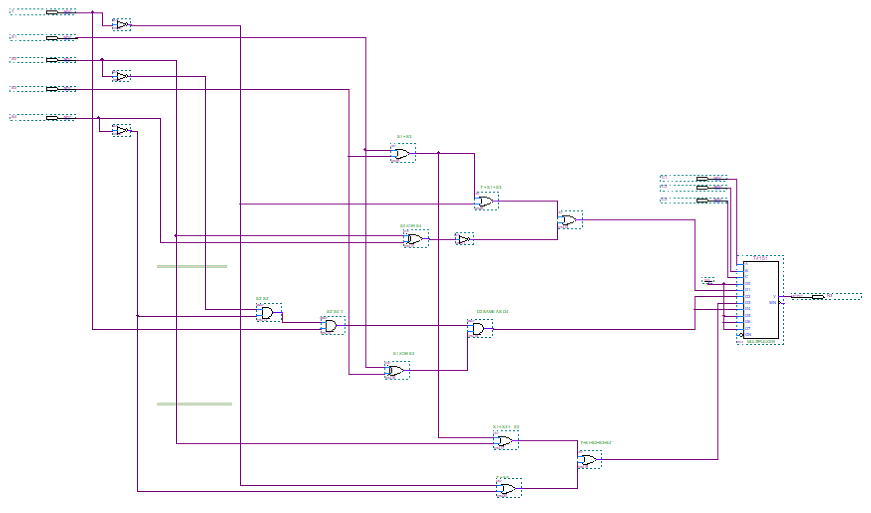

Figure 33: Quartus Circuit for N3

The circuit of N3 was compiled and simulated, the output for each sequence is then analyzed as follows:

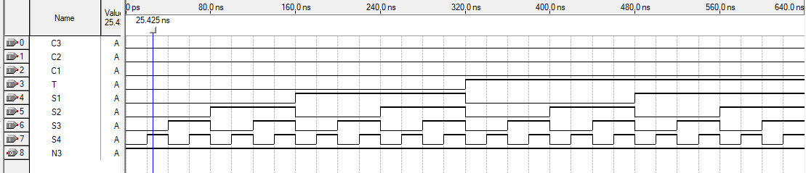

Figure 34 Simulation N3 Simulation in BOOT

In BOOT N3 is always high since the system goes to sequence 001 or 111 based on S2.

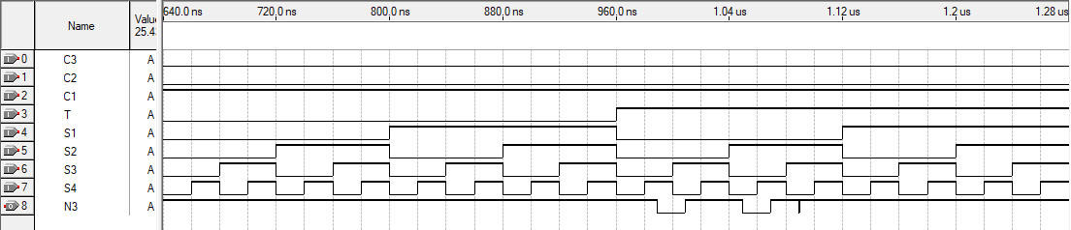

Figure 35 Simulation N3 Simulation in SEQ1

In SEQ1, N3 is always high since the system is in sequence 011. The bit only becomes low when S2 or S4 is off alone since the system goes to sequence 010 or 100.

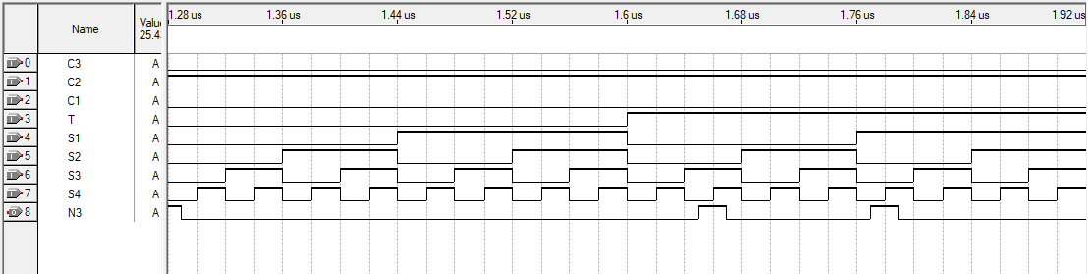

Figure 36 Simulation N3 in SEQ2

In this sequence 010, N3 is always low except when S3 or S1 is ON alone for more than 4 seconds since the system goes to sequence 011 or 001.

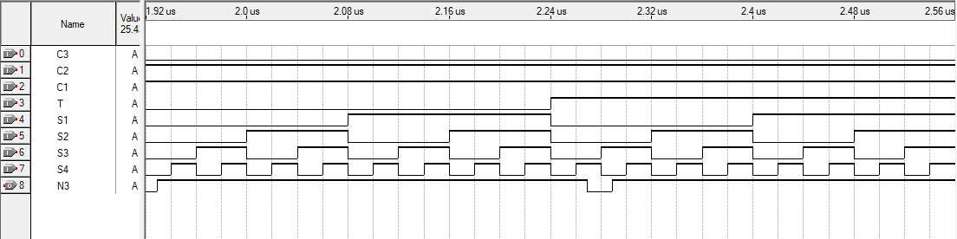

Figure 37 Simulation N3 in SEQ3

The third bit is always high since it is in sequence 001 or 101 except when S4 is ON alone for more than 4 seconds, the system goes to sequence 100 then N3 is LOW.

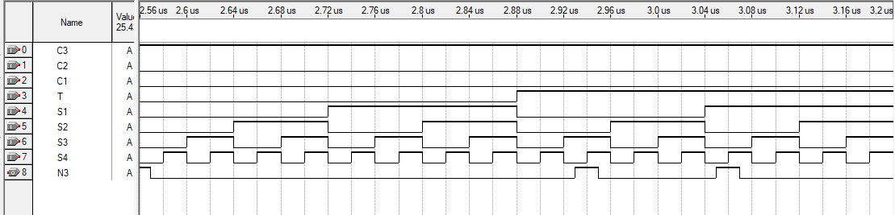

Figure 38 Simulation N3 in SEQ4

In this sequence 100, N3 is always LOW except when S3 or S1 is ON alone the system goes to sequence 011 or 001 then N3 becomes high.

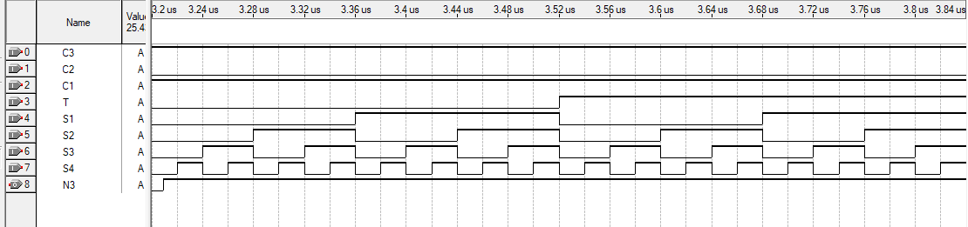

Figure 39 Simulation N3 in SEQ5

The system is either in sequence 011 or 101 then N3 is always high.

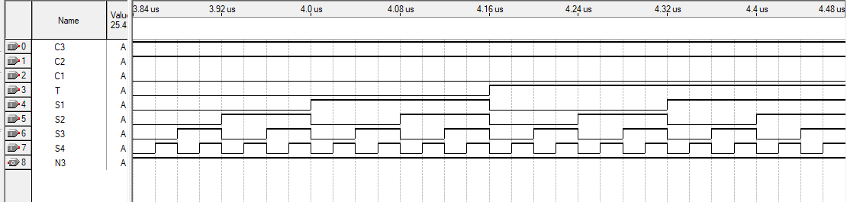

Figure 40 Simulation N3 in SEQ6

Unused state, the output N3 is always grounded.

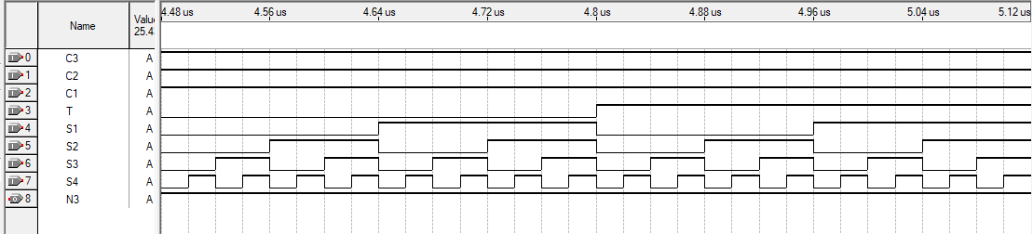

Figure 41 Simulation N3 in SEQ7

System in LOCKED state sequence 111 then output N3 is always high.

N3 was implemented on virtual breadboard as follows:

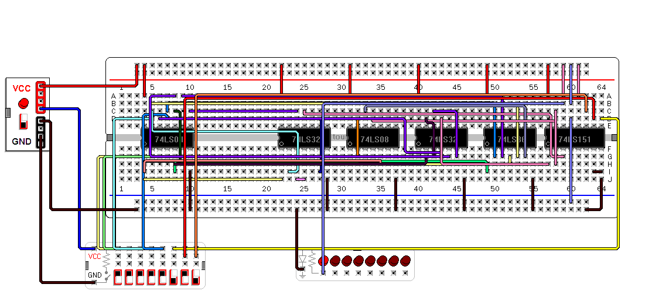

Figure 42 Special trick for N3=1

As an example, the output of N3 is always high in the Special trick although all the switches are Off .

The full circuit was implemented on Quartus. Each circuit for the bits of the next state was done as a block. The output of N1, N2 and N3 was connected as an input to the D-flip flop. The output of the D-flip-flops are used as select lines for all the multiplexers:

* C3 is the most significant bit of the next state and it corresponds to N1 of the current state.
* C2 corresponds to N2
* C1 corresponds to N3 (the least significant bit)

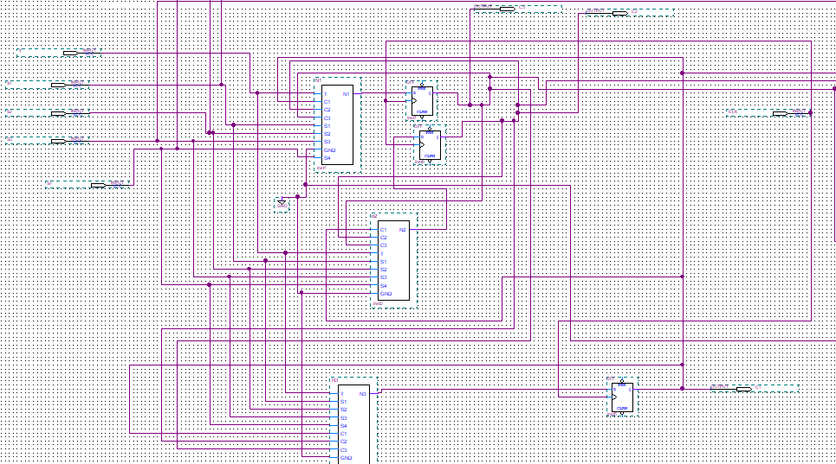

Figure 44 Full circuit Showing N1,N2,N3 blocks and D-flip flops

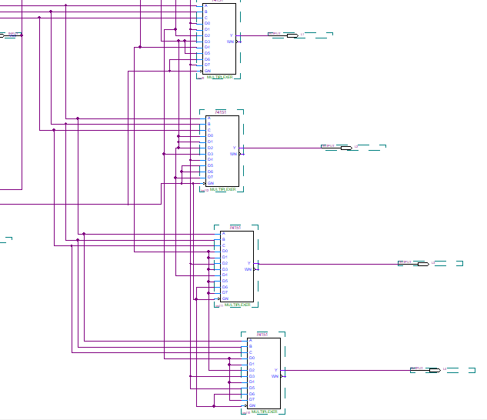

Figure 45 Full Circuit Showing L1,L2,L3 and L4 as output of MUX

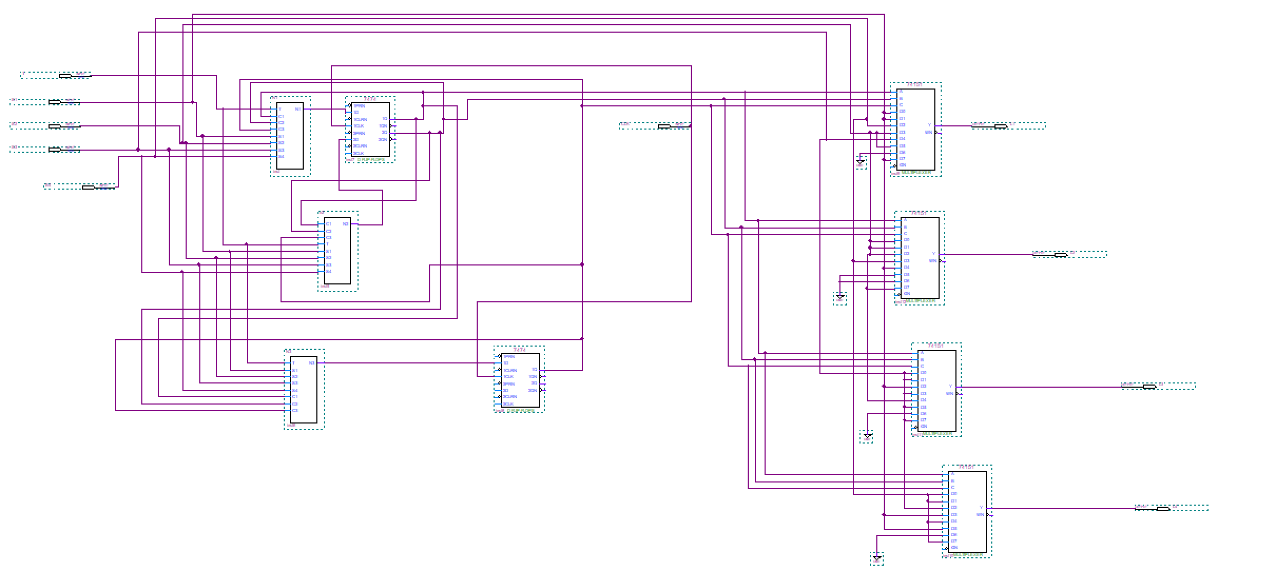

Figure 46 Entire Circuit

The full circuit was compiled and simulated as shown in the following figure:

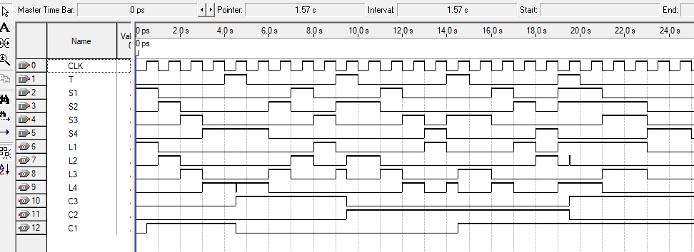

Figure 47 Simulation of Full Circuit

First, the system goes to sequence 1 directly as shown from C3, C2 and C1. In this sequence, the LEDs are turned on 1 -> 2 -> 3 -> 4 while T is 0 meaning that the timer is less than 4 seconds. Then, switch 4 is turned off last, the system goes to sequence 4 where the LEDs turn ON as per the following sequence: 4-> 3 -> 2 -> 1. Then, after 4 seconds, switch 2 was ON alone which means the design will go to sequence 2 where the LEDs will turn ON as follows: 2 -> 3 -> 4 -> 1. Then, after four seconds, switch 3 is turned off last which means the system goes to sequence 3 where the LEDs turn ON following the sequence 3 -> 4 -> 1 -> 2. When, at least two LEDs are ON with switch 4 OFF for more than 4 seconds, the system goes to the special trick which is sequence 5. In this sequence, the LEDs are mapped the same way of sequence 3 except that LED2 is always OFF and this is shown in the simulation since S4 is ON while L2 is always OFF.

# 7 segment Display Implementation

Inputs :3 bits

Outputs: 7 segments: a, b, c, d, e, f, g for each of the four seven segment displays

The truth table for the seven-segment display:

Table 16: Truth table for the 7 segment

|  |  |  |  |  |  |  |  |  |  |  |
| --- | --- | --- | --- | --- | --- | --- | --- | --- | --- | --- |
| C3 | C2 | C1 | Display | a | b | c | d | e | f | g |
| 0 | **0** | **0** | **0** | **1** | **1** | **1** | **1** | **1** | **1** | **0** |
| 0 | **0** | **1** | **1** | **0** | **1** | **1** | **0** | **0** | **0** | **0** |
| 0 | **1** | **0** | **2** | **1** | **1** | **0** | **1** | **1** | **0** | **1** |
| 0 | **1** | **1** | **3** | **1** | **1** | **1** | **1** | **0** | **0** | **1** |
| 1 | **0** | **0** | **4** | **0** | **1** | **1** | **0** | **0** | **1** | **1** |
| 1 | **0** | **1** | **Dash 1 (5) → “–”** | **1** | **0** | **0** | **0** | **0** | **0** | **1** |
| 1 | **1** | **0** | **Dash 2 (6) → “_”** | **0** | **0** | **0** | **1** | **0** | **0** | **1** |
| 1 | **1** | **1** | **L** | **0** | **0** | **0** | **1** | **1** | **1** | **0** |

From this truth table, we can derive the formulas of a, b, c, d, e , f and g:

**a:**

Table 17:K-map of a

|  |  |  |  |  |
| --- | --- | --- | --- | --- |
| C2C1  C3 | 00 | 01 | 11 | 10 |
| 0 | 1 | 0 | 1 | 1 |
| 1 | 0 | 1 | 0 | 0 |

From the k-map above:

a = C3’C2+C3’C1’+C3C2’C1

a = C3’(C2+C1’) + C3(C2’C1)

a=C3’(C2+C1’) + C3(C2+C1’)’

$$a=C3⨁(C2+C1^{'})$$

**b:**

Table 18: K-map of b

|  |  |  |  |  |
| --- | --- | --- | --- | --- |
| C2C1  C3 | 00 | 01 | 11 | 10 |
| 0 | 1 | 1 | 1 | 1 |
| 1 | 1 | 0 | 0 | 0 |

b = C2’C1’+C3’

**c:**

Table 19:K-map of c

|  |  |  |  |  |
| --- | --- | --- | --- | --- |
| C2C1  C3 | 00 | 01 | 11 | 10 |
| 0 | 1 | 1 | 1 | 0 |
| 1 | 1 | 0 | 0 | 0 |

c = C3’C1+C2’C1’

**d:**

Table 20:K-map of d

|  |  |  |  |  |
| --- | --- | --- | --- | --- |
| C2C1  C3 | 00 | 01 | 11 | 10 |
| 0 | 1 | 0 | 1 | 1 |
| 1 | 0 | 0 | 1 | 1 |

d = C2+C3’C1’

**e:**

Table 21:K-map of e

|  |  |  |  |  |
| --- | --- | --- | --- | --- |
| C2C1  C3 | 00 | 01 | 11 | 10 |
| 0 | 1 | 0 | 0 | 1 |
| 1 | 0 | 0 | 1 | 0 |

e = C3’C1’+C1C2C3

**f:**

Table 22:K-map of f

|  |  |  |  |  |
| --- | --- | --- | --- | --- |
| BC  A | 00 | 01 | 11 | 10 |
| 0 | 1 | 0 | 0 | 0 |
| 1 | 1 | 0 | 1 | 0 |

f = C2’C1’+C1C2C3

**g:**

Table 23:K-map of g

|  |  |  |  |  |
| --- | --- | --- | --- | --- |
| C2C1  C3 | 00 | 01 | 11 | 10 |
| 0 | 0 | 0 | 1 | 1 |
| 1 | 1 | 1 | 0 | 1 |

g = C3C2’+C3’C2+C3C1’= $\left(C3⨁C2\right)+C3C1'$

From the above equations, we conclude that we will use 1 XOR gate, 3 NOT gates, 6 AND gates and 7 OR gates. Thus, we will use 6 IC chips: 1 74LS86 IC(XOR), 1 74LS04 IC(NOT), 2 74LS32(OR gates), and 2 74LS08 IC(AND).

C3: brown

C2: orange

C1: yellow

VCC: yellow

Ground: black

C1’C2’(b,c,f): pink

C3’C1’(d,e): green

C1C2C3(e,f): purple

On the breadboard, the seven-segment used is a common-anode type, meaning the segments light up when the inputs are at (LOW) 0 and not at (HIGH)1. To ensure proper functionality, we inverted each input: a, b, c, d, e f and g and connected it to the seven segments. That’s why we used two additional NOT ICS.

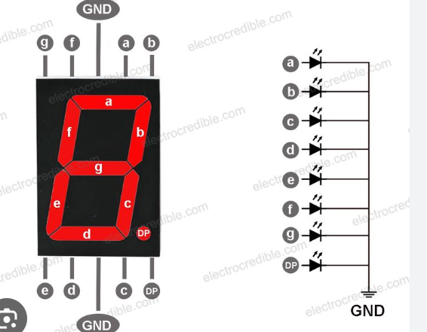Implementing on the breadboard using the IC chips XOR Gate → 74LS86, AND Gate → 74LS08, NOT Gate (Inverter) → 74LS04,OR Gate → 74LS32,jumping wires, power supply of +5V and Ground, switches and a common cathode seven segments.

Figure 48: Common cathode breadboard implementation

We ensure that the two middle pins are connected to ground in order for the common cathode to function.

First, for all the IC chips, we connect for the top right pin (14)(yellow color) to +5V and the bottom-left (pin 7) to the Ground. (black color).

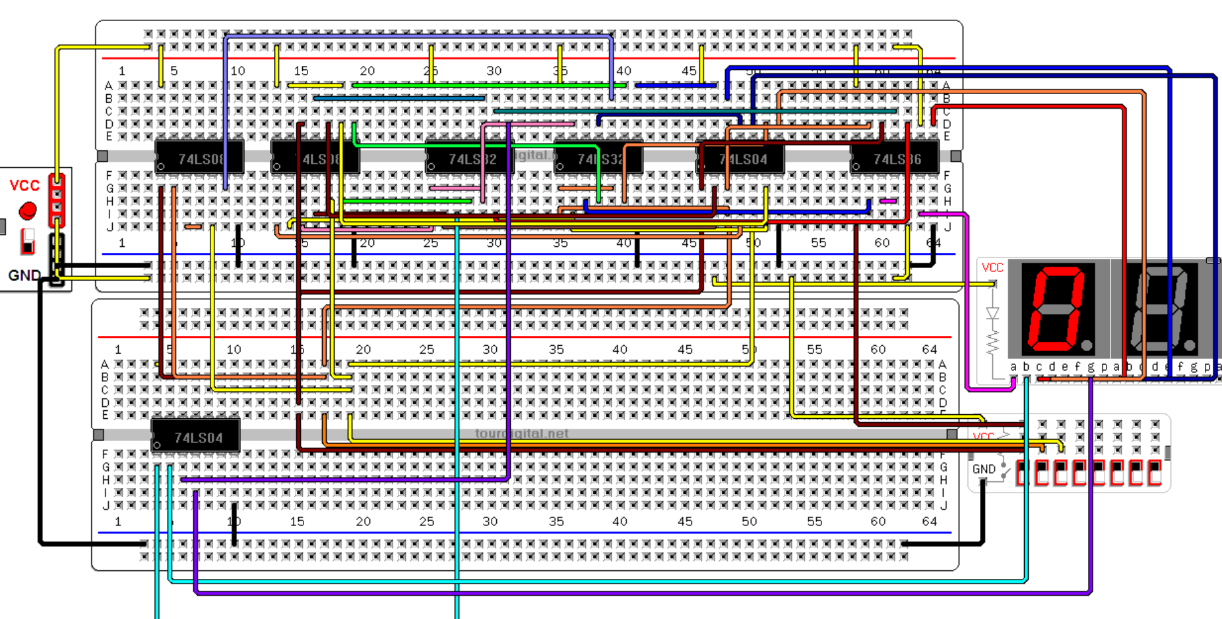

Figure 49:7 segment Boot

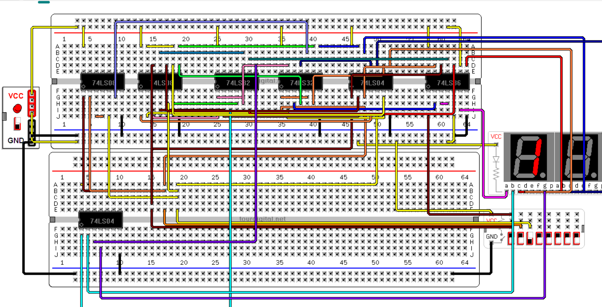

Figure 50: 7 segment Seq 1

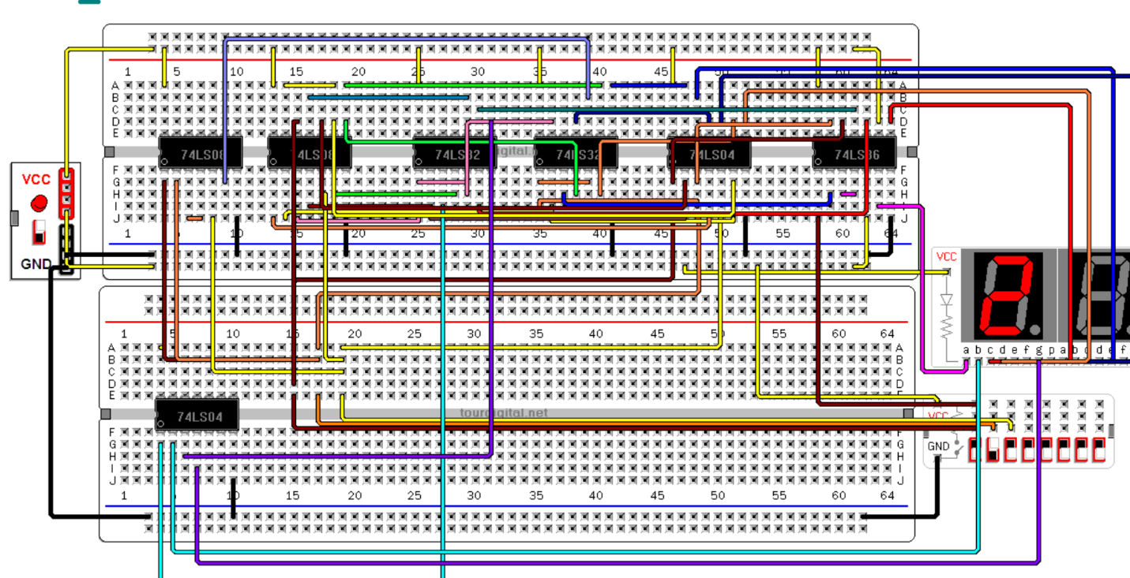

Figure 51:7 segment Seq2

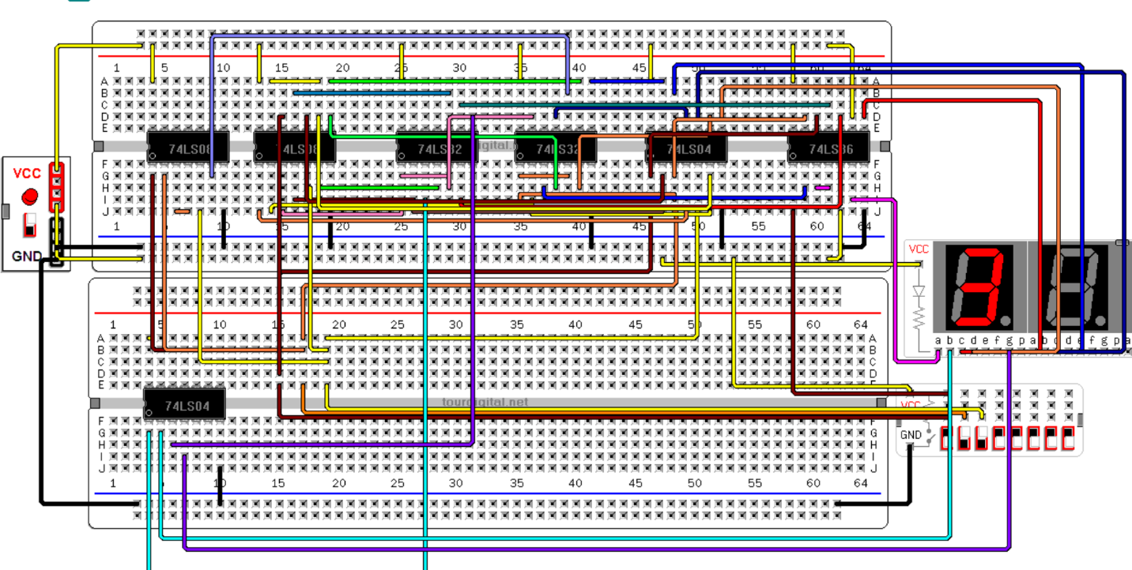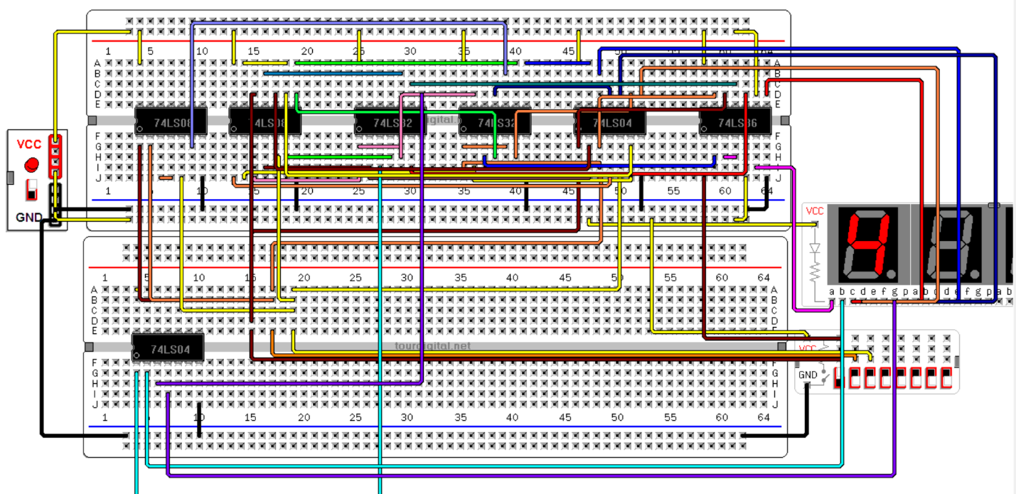 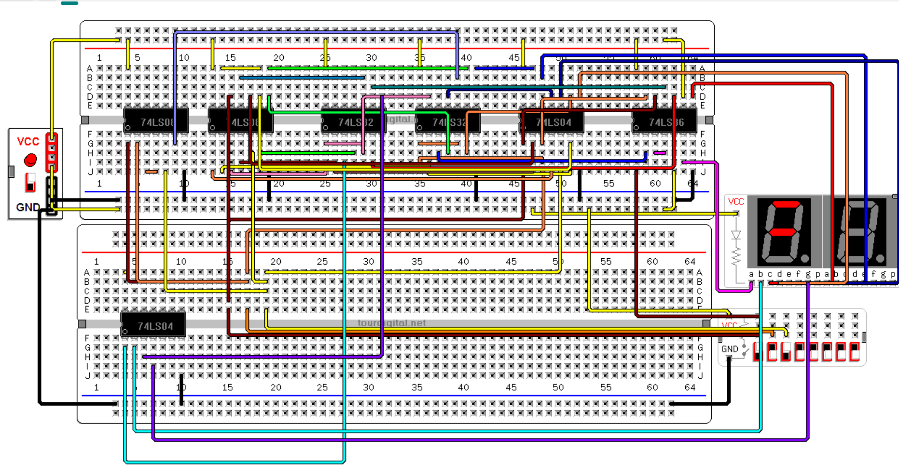

Figure 52:7 segment Seq3

Figure 53:7 segment Seq4

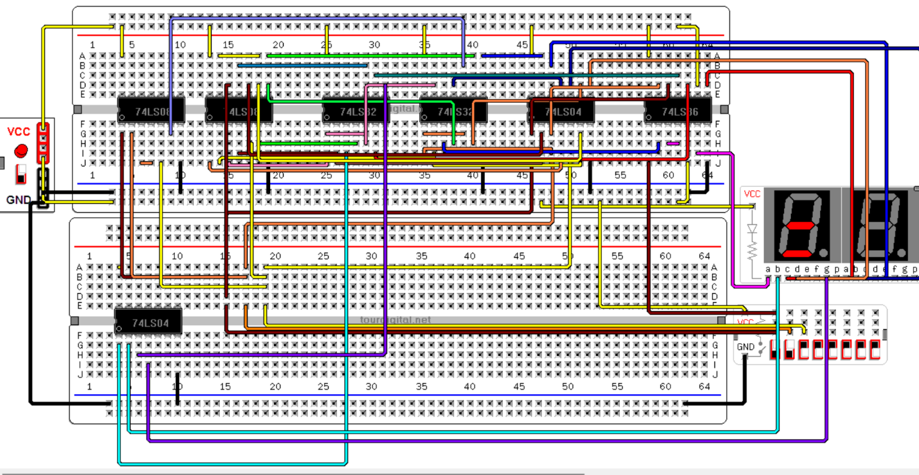Figure 55:7 segment Special Trick

Figure 54:7 segment unused state

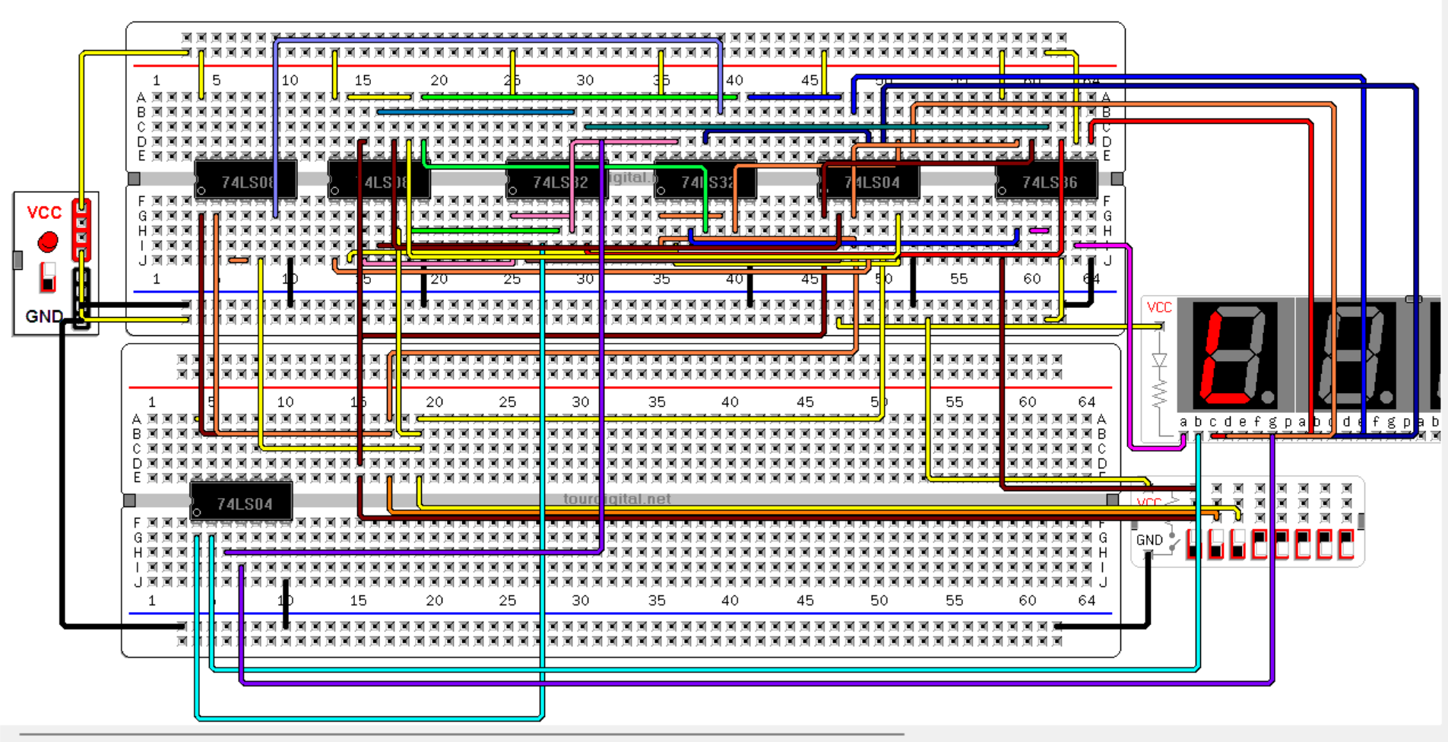

Figure 56:7 segment Locked

# Clock design

As this is a sequential circuit, we had to work with a clock.

We decided to create our own clock using a 555 timer, two capacitors and resistors.

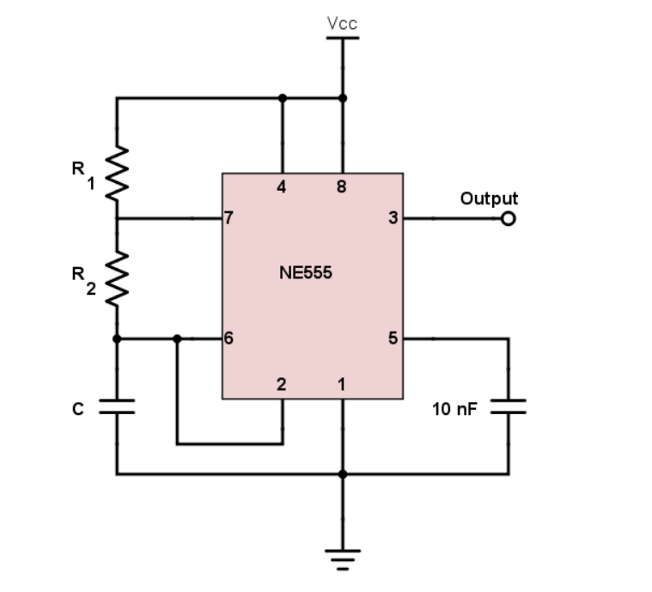The configuration looked as follows, where NE555 is the 555 timer.

Figure 57:NE555 Timer Circuit

**What is a 555 timer?**

The 555-Timer is a popular integrated circuit (IC) that is used in a variety of electronic applications such as clock timing, signal delay, pulse generation, and signal oscillation. It can produce different output waveforms by adding external RC networks.

The IC was first marketed in 1972 by Signetics and used BJTs. Since then, many companies have produced original BJT-based ICs and later low power CMOS-based ICs.

The 555 Timer is named “555” because it typically contains three 5 kilo-ohm resistors internally that form a voltage divider. It also includes two comparators, a flip-flop, a discharge transistor, and an output stage. Here is the block diagram.[1]

The output obtained will look as follows:

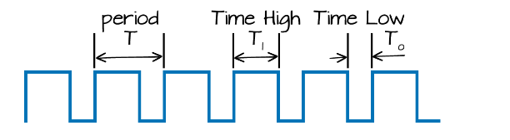

Figure 58: Clock signal output

The frequency is obtained using the formula:

$$f=\frac{1.44}{\left(R_{1}+2R_{2}\right)C}$$

For example: we want a frequency of 0.9796Hz for a period of around 1s (1.02 to be precise), with an approximate value for R1, R2, and C:

We chose C = 7 $μF;R_{1}=10kΩ;R_{2}=100kΩ$

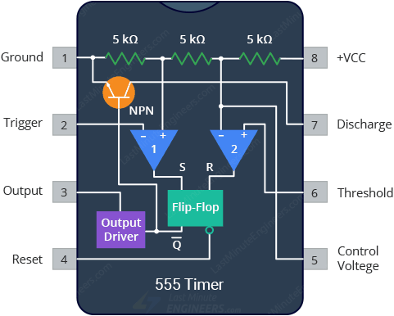

Figure 59:555 pins

The 555-Timer IC works by using three 5 kΩ resistors to divide the supply voltage in three, and two comparators to compare these voltages to the input voltage, then sets or resets a flip-flop accordingly. The flip-flop controls the output stage and a transistor that connects the discharge pin to ground.

By wiring the 555 timers with resistors and capacitors in various ways, you can get it to operate in three different modes: Monostable, Astable, and Bistable.

For the clock, we built the astable mode and for the timer we can built the monostable mode.

• **Astable**: No stable state; keep switching (e.g., LED blinker).

• **Monostable**: One stable state; gives a single pulse when triggered (e.g., timer).

• **Bistable**: Two stable states; toggles state on each trigger (e.g., switch, memory latch).

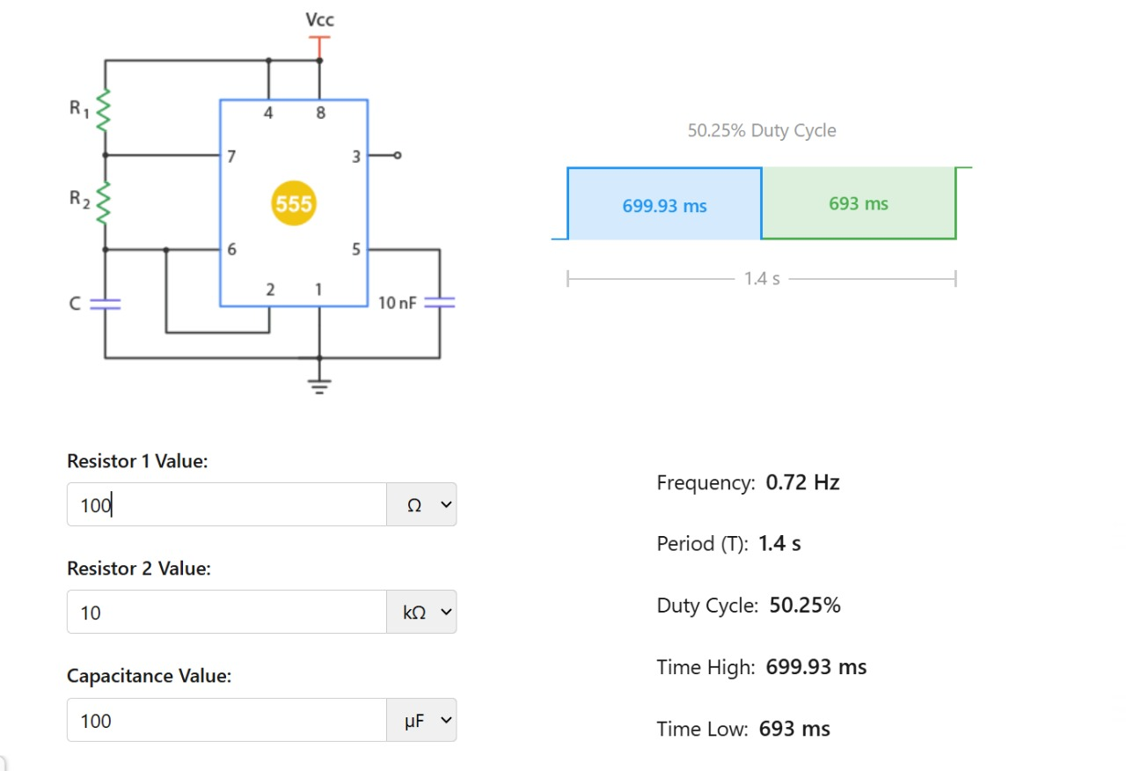

Figure 60:Resistors and Capacitors used for the clock implementation

In Astable mode, the 555-timer IC forms a Resistance-Capacitance circuit with two external resistors (R1 and R2), and an external capacitor (C). The circuit generates a continuous rectangular wave output signal, the frequency and duty cycle of which are determined by the resistance and capacitance values of the circuit. That’s why this mode is also known as a Free Running Mode.

In this mode, when the 555-timer is powered on for the first time, the capacitor (C) starts to charge through resistors R1 and R2, driving the output signal high. As the voltage across the capacitor increases, it eventually reaches the upper threshold voltage (2/3 VCC) of the internal comparator. At this point, the flip-flop is triggered, and the output pin (pin 3) goes high.

When the output pin goes high, the discharge pin (pin 7) is connected to ground, causing the external capacitor (C) to discharge rapidly through resistor R2. The capacitor discharges until it reaches the lower threshold voltage (1/3 VCC) of the internal comparator. Once the capacitor voltage drops to the lower threshold, the flip-flop is reset, and the output pin (pin 3) goes low again. The capacitor then starts charging once again, repeating the cycle.[1]

The frequency and duty cycle of the square wave generated by the astable circuit depend on the values of resistors R1 and R2, as well as the capacitor value (C).

The period is the time covered for one pulse and is just the reciprocal of the frequency:

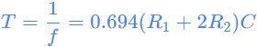

The high time (TH) and low time (TL) are the durations of the output being at VCC and 0 volts respectively. They are given by the formulas:

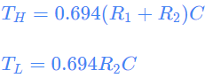

Note that the period (T) is the sum of the high time and the low time.



The duty cycle of the output waveform is the ratio of time the output is high (TH) to the total period (T). It can be calculated using the following equation:



**For the timer we will use the monostable mode in order to generate a timer of 4 s**

Then, a reset is needed each time the system goes to another sequence. when the system goes to another sequence, the timer goes back to 0 and counts to outputs 1 when it reaches 4 seconds.

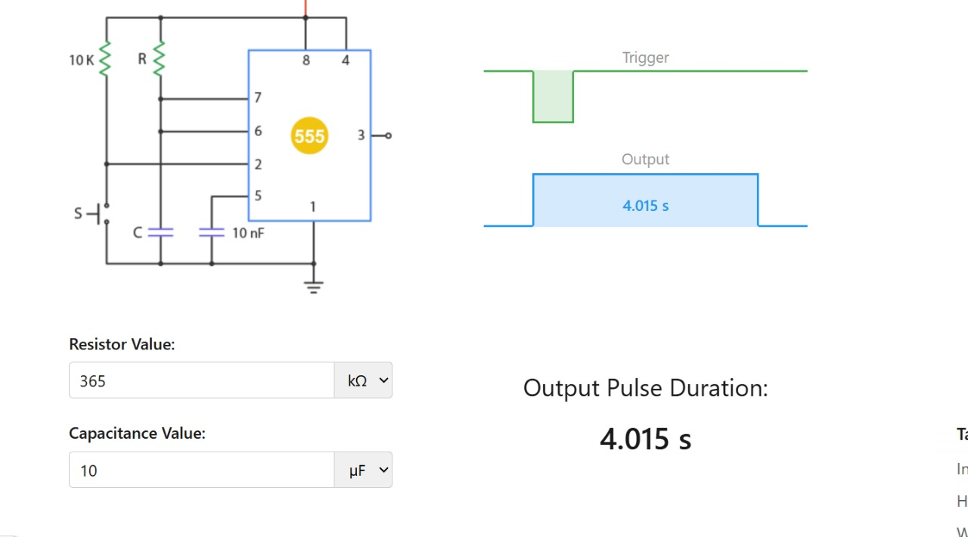

Figure 61:Monostable timer of 4 s

In Monostable mode, the 555-timer IC forms a Resistance-Capacitance circuit with the external resistor and capacitor. The circuit generates a single, short, positive pulse of a specific duration in response to a trigger signal (when a falling edge is detected on pin 2). That’s why the circuit is also known as a one-shot circuit.[2]

In this mode, when the input signal is applied to the trigger pin (pin 2), the output (pin 3) of the IC goes high and the external capacitor begins to charge. When the voltage across the capacitor equals 2/3 of the IC’s supply voltage, the capacitor stops charging and the output signal of the circuit returns to the low state, ready for the next input signal.

The duration of the pulse can be shortened or extended by adjusting the value of the resistor and capacitor, changing the rate that the capacitor charges.

The duration of the pulse (T) can be calculated using the following equation:



Where:

T is the output pulse width (in seconds)

R is the resistance (in ohms) connected to the pin 7 of the IC

C is the capacitance (in farads) connected to the pin 6 of the IC[2]

**Bistable Mode of the 555 Timer**

The 555 timer in bistable mode is also known as a flip-flop circuit. A flip-flop circuit alternates between two stable states, in this case the output of electrical current from the output pin. Unlike the monostable mode and astable modes, bistable mode doesn’t need a resistor and capacitor to set the timing of the circuit. In fact there is no timing in this circuit. There are only two stable states (on and off) controlled directly by the trigger pin and reset pin.[3]

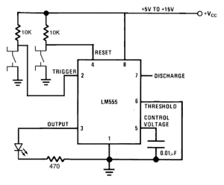

Figure 62:Bistable 555 timer

# Financial Study

To complete the project successfully, we worked on achieving a successful implementation while also taking into consideration its efficiency. One of our primary objectives was to minimize the cost of the project wherever possible. Reducing the cost of the project would not only benefit us but would also show that we were capable of completing the task efficiently. To achieve this, we adopted a few strategies.

First, we simplified the design as much as possible, aiming to use the minimum number of gates necessary for the project.

We then designed the circuit in a way to reuse previously made combinations, which allowed us to minimize repetitions.

We also decided not to extremely precise components because we recognized they weren't essential for our project and that they were much more expensive than lower-accuracy components that would achieve similar results.

By employing these techniques, we were able to keep our costs relatively low.

However, we encountered some challenges that made it necessary to prioritize simplicity over cost in certain situations, in the process of minimizing the cost of the project.

For example, we found that in some cases, it was difficult to physically reuse components as they would make our circuits messy and hard to debug.

In other situations, as much as we tried to use the entirety of logic gates in each chip to create other logic gates, we sometimes relied on additional components.

Additionally, we found our INVERTER gates to be faulty and had to use substitutes and buy more components.

Below is the price list of the components bought for this project:

Table : Price List

|  |  |  |
| --- | --- | --- |
| **Item** | **Quantity** | **Price ($)** |
| 74LS08 | 10 | 4.5 |
| 74LS32 | 10 | 3 |
| 74LS04 | 6 | 1.8 |
| 74LS74 | 6 | 2.1 |
| 74LS47 | 8 | 2.8 |
| 74LS86 | 5 | 2.5 |
| 74LS151 | 10 | 15 |
| LM555 Timer | 3 | 0.75 |
| Breadboards | 8 | 69 |
| Power Supply Module | 2 | 3 |
| 7 Segment Common Anode | 4 | 1.4 |
| 220 $Ω$ Resistors | 10 | - |
| Switches | 10 | 5 |
| 5V Power Supply | 1 | 2 |
| Wires | 10 | 10 |
| Green LED | 1 | 0.05 |
| Yellow LED | 3 | 0.05 |
| Red LED | 1 | 0.05 |
| 100k $Ω$ Resistor | 10 | - |
| 2.2k $Ω$ Resistor | 10 | - |
| 3.3uF Capacitor | 3 | 0.15 |
| 10nF Capacitor | 3 | 0.15 |
| 100µF Capacitor | 3 | 0.15 |
| **Total Price** |  | **123.45$** |

An inconvenience we faced was the price of the breadboards as they were available in limited quantities. We would have wanted to implement the entire circuit on a singular large breadboard instead, but this was not feasible.

# Power consumption

We are using a 9V input DC source along with a Power Supply Module connected to a large number of ICs connected together. Assuming a typical power consumption of 10 milliwatts (mW) per 74LS logic gate at a supply voltage of 5 volts, the approximate power consumption for each component in your list can be calculated as follows:

25 * 74LS08 AND gates = 250 mW

20 * 74LS32 OR gates = 200 mW

9 * 74LS04 inverter gates = 90 mW

4 * 74LS74 D flip-flops = 40 mW

3 * 74LS86 XOR gates = 30 mW

7 * 74LS151 8:1 MUX = 700mW

4 * 7-segment common anode displays = 200mW in total (50 each)

220-ohm resistors = negligible power consumption

4* switches = negligible power consumption

1 * green LED = negligible power consumption

1 * yellow LEDs = negligible power consumption

1 * red LED = negligible power consumption

1 * blue LED = negligible power consumption

100kohm resistors = negligible power consumption

2.2kohm resistors = negligible power consumption

3.3uF capacitors = negligible power consumption

3 * 10nF capacitors = negligible power consumption

1 * NE555 timer IC = 100mW

The entire power consumption of our circuit averaged around 1700mW.

# Delays

Table : Delay Table

|  |  |  |  |
| --- | --- | --- | --- |
| IC Chip | Average Delay | Quantity of Gates Used | Delay calculated |
| 74LS08 | 15ns | 25 | 375ns |
| 74LS32 | 20ns | 20 | 400ns |
| 74LS04 | 10ns | 15 | 150ns |
| 74LS74 | 20ns | 4 | 80ns |
| 74LS86 | 25ns | 3 | 75ns |
| 74LS151 | 30ns | 7 | 210ns |

Delays were inevitable as we were implementing our circuit. Although they were not noticeable in the testing process, they were easily detectable in our software simulations.

To represent the delays in a clear manner, we calculated their values and put them in the table above.

The total delay depends on the longest path of gates in the circuit.

We were aware that those delays could affect not the response time of circuit, but also the time required to attain certain states, as for instance, they could affect the precision of 4 seconds set by the timer, or the conditions that would activate other results. However, in our situation, delays did not have a significant impact on our design.

# Problems Faced

1. **Comprehending Inputs, Outputs and States:** A major challenge was understanding the system's diverse inputs and outputs. We had to ensure the system was designed in an efficient manner with little to no repetitive implementations, and a clear representation of the outcomes. Extensive research and teamwork were necessary to align all members and fully understand the specifications.
2. **Managing Extensive State Table Combinations:** Designing the state was not a simple task as there are multiple ways of achieving similar results. We had to account for potential scenarios and construct truth tables tailored to each one of them. This demanded thorough planning and precise attention to detail to avoid missing any cases and to ensure the table could manage the situations corresponding to the logic it was built on.
3. **Virtual Breadboard and Software Issues**: We struggled with virtual breadboard and simulation tools that were not intuitive. Ultimately, we selected Virtual Breadboard and Altera Quartus II for circuit design and simulation, but their complex and tightly limited interface made circuit design challenging. We dedicated considerable time to adjusting the software and experimenting with its features to meet the project’s demands.
4. **Clock Design:** Developing a clock to synchronize system components required in-depth circuit knowledge. Research was done to determine the design as well as the components that could lead to a more efficient and less prone to error clock implementation.
5. **Soldering Complexities**: We attempted to solder the clock component multiple times, but it consistently failed to function as expected.
6. **Gates problems**: we discovered that a high number of gates we bought was damaged before using them. This caused high inefficiency and wasted a lot of time since we were obliged to test each output alone and check every combination of the truth table.

# References

[1] L. E. Staff, “555 Timer Astable Circuit Calculator,” *Last Minute Engineers*, Jul. 19, 2023. <https://lastminuteengineers.com/555-timer-astable-circuit-calculator/>

‌[2] L. E. Staff, “555 Timer Monostable Circuit Calculator,” *Last Minute Engineers*, Jul. 19, 2023. <https://lastminuteengineers.com/555-timer-monostable-circuit-calculator/>

[3] S. C. | D. Electronics | 8, “555 Timer Basics - Bistable Mode,” *Circuit Basics*, Jan. 03, 2015. https://www.circuitbasics.com/555-timer-basics-bistable-mode/

‌ [4] Fairchild Semiconductor. *74C08 Quad 2-Input AND Gate Datasheet*. Retrieved from: https://www.alldatasheet.com/datasheet-pdf/pdf/230205/FAIRCHILD/74C08.html

[5] Futurlec. *74LS32 Quad 2-Input OR Gate Datasheet*. Retrieved from: https://www.futurlec.com/74LS/74LS32.shtml

[6] Future. *74LS86 Quad 2-Input XOR Gate Datasheet*. Retrieved from: https://www.futurlec.com/74LS/74LS86.shtml

[7] Futurlec. *74LS151 8-Input Multiplexer Datasheet*. Retrieved from: https://www.futurlec.com/74LS/74LS151.shtml

‌